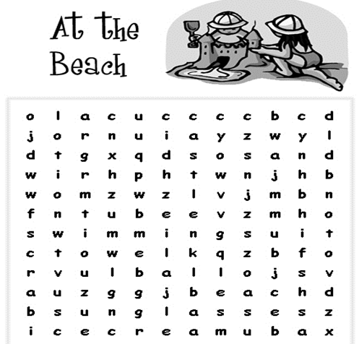Beach

Sun

Swim

Ball