Tasks for the Summative Assessment for the term 3

- Прочти текст и выполни задания.

Reading. 5 баллов

Dolphin Dreams
Dolphin Dreams is a perfect holiday! We take people in our boats and we visit dolphins in the sea. You can swim with beautiful dolphins!
Do you know…?
- Dolphins aren’t dangerous. They are very friendly. They love playing with people.
- Dolphins can’t breathe under water, but they can stay under water for about 15 minutes.
- Dolphins live in families
- Dolphins have names. Their names are special sounds. They use the sounds to call their friends and family.
- Dolphins can’t live in polluted water, but a lot of the sea is polluted. We want to make the sea a clean and safe place for dolphins

Составь предложения, используя слова в рамочке. Пиши только одно слово!

to pollute a danger beauty to clean a friend

- Dolphins aren’t ugly. They are _________________________________. [1]
- Dolphins can’t live in polluted water. They live in ____________water. [1]
- Dolphins are safe. They aren’t _________________________________. [1]
- Dolphins are not aggressive. They are ___________________________. [1]
- A lot of the sea isn’t clean. It is ______________________ [1]

- Grammar. Составь предложения, используя глаголы в Past Simple. 6 баллов

Пиши только одно слово!

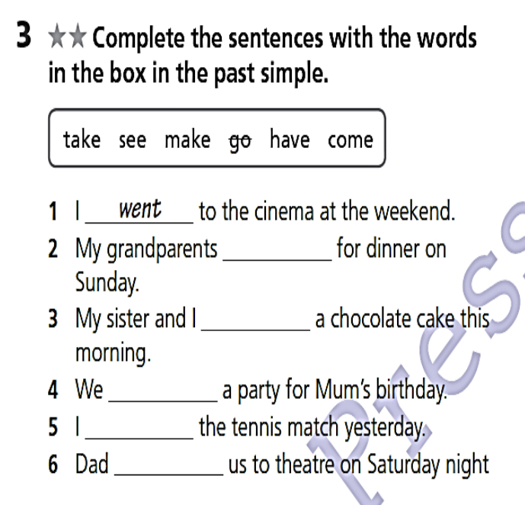

- Vocabulary. Подбери правильно слова к предложениям. Пиши только одно слово!

6 баллов

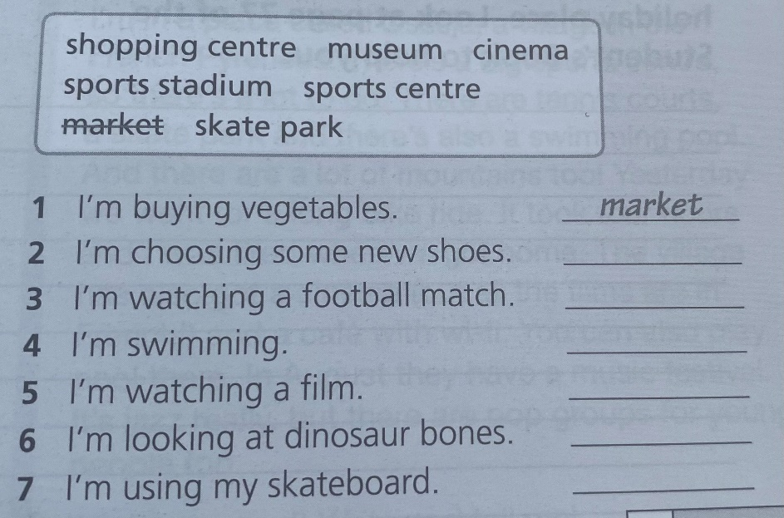

- Составь с данными словами любые 3 предложения и запиши их. ( 3 балла)

Итого: 20 баллов.

