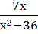 + =
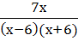 - =
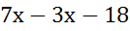=7х-42
-3х+24=0
-3х=-24
Х=8

