**Tasks for the Summative Assessment for the term 2**

**I. Reading**

**Task 1. Read the Naulan’s blog**

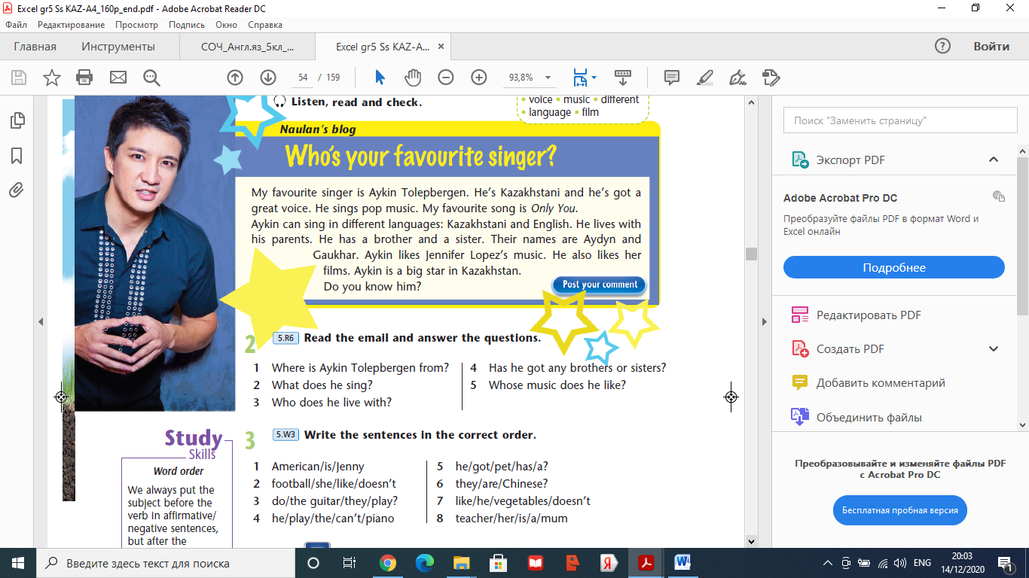

**Read the text again and answer the questions (Прочитай текст еще раз и ответь на вопросы ПОЛНЫМИ предложениями из текста)**

1. Where is Aykin Tolepbergen from?
2. What does he sing?
3. Who does he live with?
4. Has he got any brothers or sisters?
5. Whose music does he like?

**Total [5]**

**II. Writing**

**Task 2.** **Write the sentences in the correct order. (Напиши предложения в правильном порядке)**

1. football/ she/ like/ doesn’t.
2. do/ the guitar/ they/ play?
3. he/ play/ the/ can’t/ piano.
4. he/ got/ pet/ has/ a?
5. they/ are/ Chinese?
6. like/ he/ vegetables/ doesn’t.
7. teacher/ her/ is/ mum.

**Total [7]**

**Task 3. Collect information about your favourite singer. Answer the questions. (Запиши ответы на вопросы о своем любимом певце. Отвечай на вопросы ПОЛНЫМИ предложениями)**

1. Who’s your favourite singer?
2. Where is he/she from?
3. Why do you like this singer?

**Total [3]**

**Total marks 15**