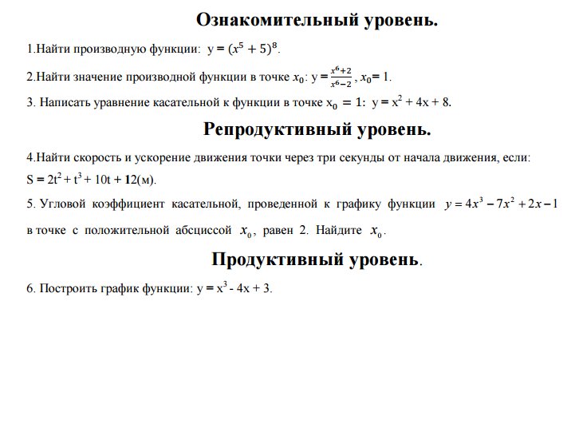

V(t)=s’(t)

S’(t)=(2t2+t3+10t+12)’=4t+3t2+10

V(t)=3t2+4t+10

V(3)=3*32+4*3+10=49

**V(3)=49 м/сек**