|  |  |  |  |  |  |
| --- | --- | --- | --- | --- | --- |
| $$Інтервал$$ $$[α_{i-1};α_{i})$$ | **2-4** | **4-6** | **6-8** | **8-10** | **10-12** |
| $$n_{i}$$ | 10 | 5 | 20 | 10 | 88 |
| p | $$\frac{10}{133}$$ | $$\frac{5}{133}$$ | $$\frac{20}{133}$$ | $$\frac{10}{133}$$ | $$\frac{88}{133}$$ |

n = 133

Перейдем от интервального статичного распределения к дискретному благодаря формуле:

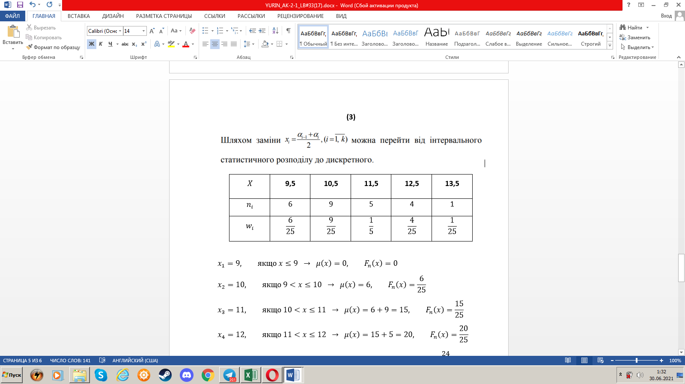

|  |  |  |  |  |  |
| --- | --- | --- | --- | --- | --- |
| $$Інтервал$$ $$[α_{i-1};α_{i})$$ | **3** | **5** | **7** | **9** | **11** |
| $$n_{i}$$ | 10 | 5 | 20 | 10 | 88 |
| p |  |  |  |  |  |

