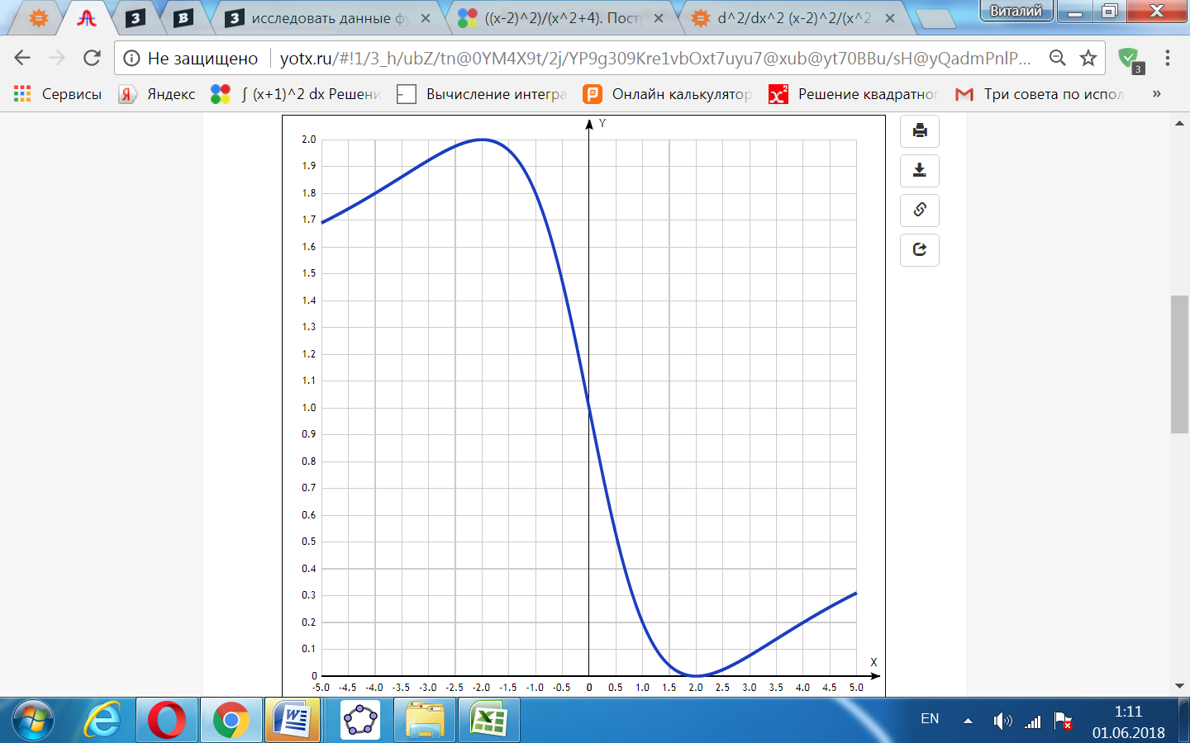

[Таблица точек](javascript:void(0);)

|  |  |
| --- | --- |
| **x** | **y** |
| -5.0 | 1.69 |
| -4.5 | 1.74 |
| -4.0 | 1.8 |
| -3.5 | 1.86 |
| -3.0 | 1.92 |
| -2.5 | 1.98 |
| -2.0 | 2 |
| -1.5 | 1.96 |
| -1.0 | 1.8 |
| -0.5 | 1.47 |
| 0 | 1 |
| 0.5 | 0.53 |
| 1.0 | 0.2 |
| 1.5 | 0.04 |
| 2.0 | 0 |
| 2.5 | 0.02 |
| 3.0 | 0.08 |
| 3.5 | 0.14 |
| 4.0 | 0.2 |
| 4.5 | 0.26 |
| 5.0 | 0.31 |