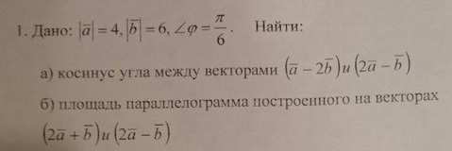
$$\begin{aligned}\left|\overline{a}−2\overline{b}\right|=\sqrt{\left(\overline{a}−2\overline{b}\right)\left(\overline{a}−2\overline{b}\right)}=\sqrt{{\left(\overline{a}\right)}^{2}−4\overline{a}\overline{b}+4{\left(\overline{b}\right)}^{2}}=\sqrt{4^{2}−4∗4∗6\text{*cos}\left(\frac{π}{6}\right)+4∗6^{2}}= \\ 4\sqrt{1−6\text{*cos}\left(\frac{π}{6}\right)+9}=4\sqrt{\text{10}−3∗\sqrt{3}} \\ \left|\overline{2a}+\overline{b}\right|=4\sqrt{4+3∗\sqrt{3}+\frac{9}{4}} \\ \left(\overline{a}−2\overline{b}\right)\left(2\overline{a}+\overline{b}\right)=2{\left(\overline{a}\right)}^{2}−2{\left(\overline{b}\right)}^{2}−3\overline{a}\overline{b}=2∗4^{2}−2∗6^{2}−3∗4∗6\text{*cos}\left(\frac{π}{6}\right)= \\ \left|\overline{a}−2\overline{b}\right|∗\left|\overline{2a}+\overline{b}\right|\text{*cos}(x) \\ \text{cos}(x)=\frac{2∗4^{2}−2∗6^{2}−3∗4∗6\text{*cos}\left(\frac{π}{6}\right)}{4\sqrt{\text{10}−3∗\sqrt{3}}∗4\sqrt{4+3∗\sqrt{3}+\frac{9}{4}}} \\ \text{sin}(x)=\sqrt{1−{\text{cos}}^{2}(x)} \\ S=\left|\overline{a}−2\overline{b}\right|∗\left|\overline{2a}+\overline{b}\right|\text{*sin}(x)=\text{60}\end{aligned}$$

