Look at the family tree and fill in the missing words.
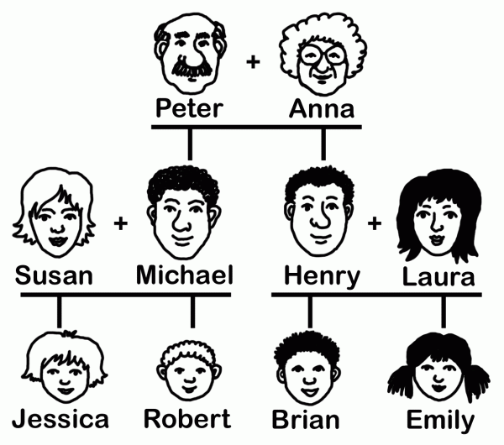

Down:
- Anna is Brian's …………………
- Jessica is Susan's …………………
- Michael is Robert's …………………
- Henry is Laura's …………………
- Emily is Brian's …………………
- Henry is Robert's …………………
- Brian is Henry's …………………
- Robert is Henry's …………………
Across:
- Peter is Jessica's …………………
- Robert is Brian's …………………
- Anna is Peter's …………………
- Laura is Emily's …………………
- Laura is Jessica's …………………
- Emily is Michael's …………………
- Brian is Emily's …………………

