https://znanija.com/task/516034
$$y=x^{2}-6x+5$$
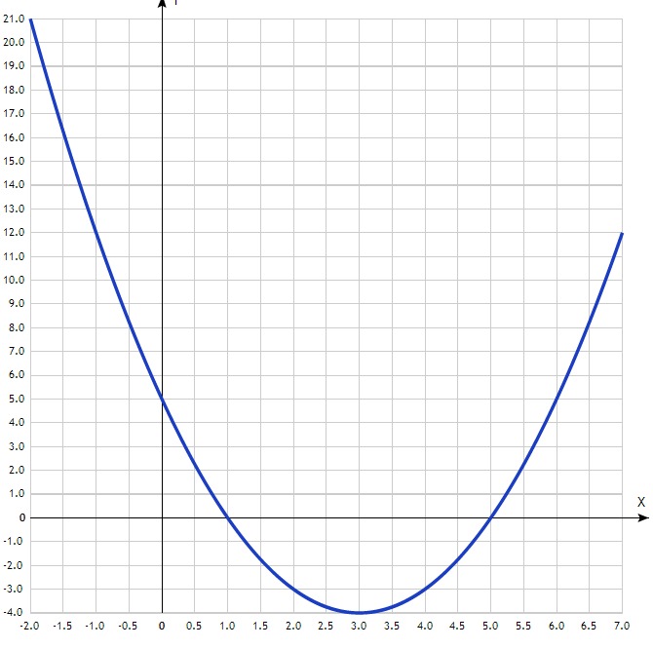

x | y
-2.0 | 21
-1.5 | 16.25
-1.0 | 12
-0.5 | 8.25
0 | 5
0.5 | 2.25
1.0 | 0
1.5 | -1.75
2.0 | -3
2.5 | -3.75
3.0 | -4
3.5 | -3.75
4.0 | -3
4.5 | -1.75
5.0 | 0
5.5 | 2.25
6.0 | 5
6.5 | 8.25
7.0 | 12

