Контрольная работа за 2 полугодие.
Spotlight 7. Modular test 6-10.
Variant II
Vocabulary and grammar.
Task A.
1 | 9
2 | 10
3 | 11
4 | 12
5 | 13
6
7
8
Everyday English
Task B
1. 2.
3. 4.
5.
Reading.
Task C.
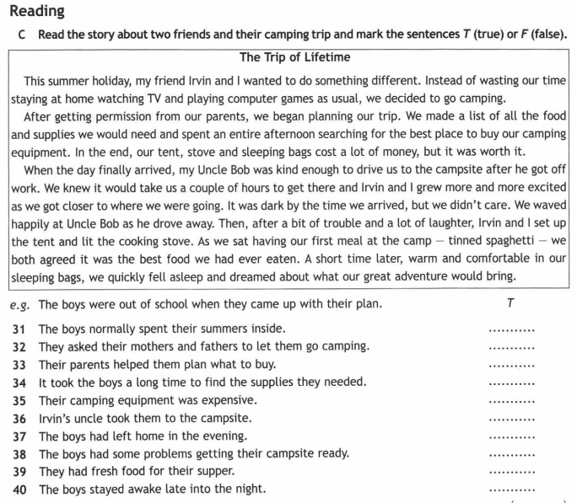

Writing.
Task D.

