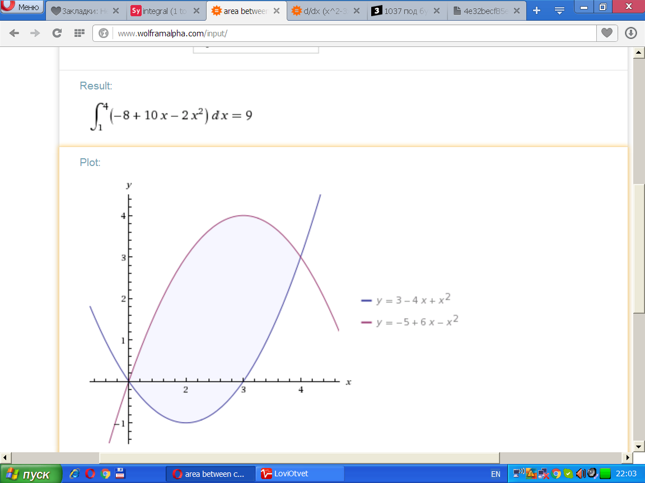

y(x)=x2−4x+3 [Таблица точек](javascript:void(0);)

|  |  |
| --- | --- |
| **x** | **y** |
| 0.0 | 3 |
| 0.5 | 1.25 |
| 1.0 | 0 |
| 1.5 | -0.75 |
| 2.0 | -1 |
| 2.5 | -0.75 |
| 3.0 | 0 |
| 3.5 | 1.25 |
| 4.0 | 3 |
| 4.5 | 5.25 |
| 5.0 | 8 |

y(x)=−x2+6x−5y [Таблица точек](javascript:void(0);)

|  |  |
| --- | --- |
| **x** | **y** |
| 0.0 | -5 |
| 0.5 | -2.25 |
| 1.0 | 0 |
| 1.5 | 1.75 |
| 2.0 | 3 |
| 2.5 | 3.75 |
| 3.0 | 4 |
| 3.5 | 3.75 |
| 4.0 | 3 |
| 4.5 | 1.75 |
| 5.0 | 0 |