
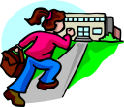


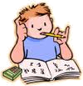

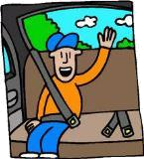
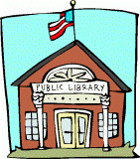
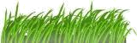
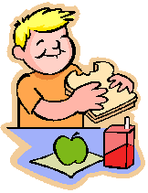
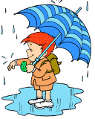

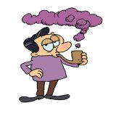


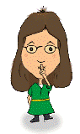
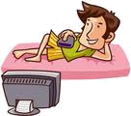

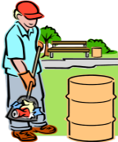
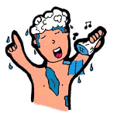

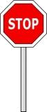


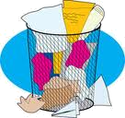

Complete the sentences with must or mustn’t.
You _ _ _ _ _ be late for school.
You _ _ _ _ _ go to the dentist with a toothache.
A teacher _ _ _ be a patient person.
You _ _ _ _ _ speak loudly in a library.
It’s raining. You
_ _ _ _ _ take your umbrella.
You _ _ _ _ _ stop when you see that sign.
You _ _ _ _ _ eat in class.
You _ _ _ _ _ keep off the grass!
You _ _ _ _ _ take a cough syrup once a day.
You _ _ _ _ _ tell my secret to anybody.
You _ _ _ _ _ watch too much television.
You _ _ _ _ _ fasten your seat belt in a car.
You _ _ _ _ _ eat junk food too often.
You _ _ _ _ _ feed your pet twice a day.
You _ _ _ _ _ run with a broken leg.
We _ _ _ _ _ protect endangered species.
You _ _ _ _ _ have a shower every day.
You _ _ _ _ _ forget about Mother’s Day.
You _ _ _ _ _ put the rubbish in a bin.
You _ _ _ _ _ eat more fruit.
You _ _ _ _ _ listen to loud music after 10 p.m.
You _ _ _ _ _ stop smoking. It’s bad for you.
Students _ _ _ _ forget their homework.

You _ _ _ _ _ keep the park clean.
You have a sore throat. You _ _ _ _ _ eat ice cream.

