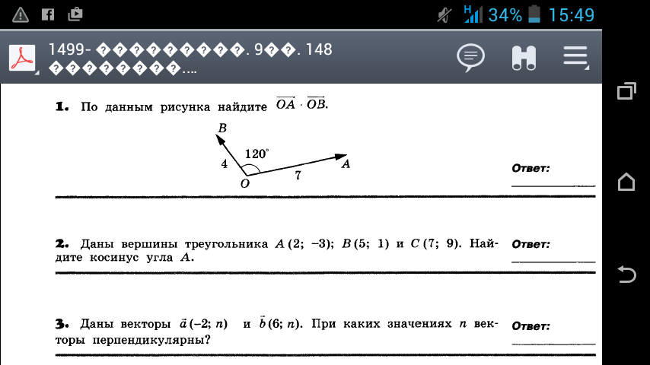
$\begin{aligned}\text{cos}ϕ=\frac{\vec{a}⋅\vec{b}}{\left|a\right|⋅\left|b\right|}\text{.} \\ \text{cos}{\text{120}}^{0}=\frac{\vec{\text{OA}}⋅\vec{\text{OB}}}{4⋅7}, −\frac{1}{2}=\frac{\vec{\text{OA}}⋅\vec{\text{OB}}}{\text{28}}, \vec{a}⋅\vec{b}=−\text{14}\end{aligned}$
$$\begin{aligned}№2\text{.} A\left(2;−3\right) B\left(5;1\right) С\left(7;9\right) \\ \overset{→}{\text{AB}}\left\{5−2;1−\left(−3\right)\right\} \overset{→}{\text{AB}}\left\{3;4\right\} \\ \left|\overset{→}{\text{AB}}\right|=\sqrt{3^{2}+4^{2}}=\sqrt{\text{25}}=5 \\ \overset{→}{\text{AC}}\left\{7−2;9−\left(−3\right)\right\} \overset{→}{\text{AB}}\left\{5;\text{12}\right\} \\ \left|\overset{→}{\text{AB}}\right|=\sqrt{5^{2}+{\text{12}}^{2}}=\sqrt{\text{144}}=\text{13} \\ \text{cos}A=\frac{\overset{→}{\text{AB}}⋅\overset{→}{\text{AC}}}{\left|\overset{→}{\text{AB}}\right|⋅ \left|\overset{→}{\text{AC}}\right|}, \text{cos}A=\frac{3⋅5+4⋅\text{12}}{5⋅\text{13}}=\frac{\text{63}}{\text{65}}\end{aligned}$$
$$\begin{aligned}№3\text{.} \overset{→}{a}\left\{−2;n\right\}, \overset{→}{b}\left\{6;n\right\} \\ \text{cos} \\ \end{aligned}\begin{aligned}\left( | \right) \\ \end{aligned}$$

