√(3х – а) = х – 3а

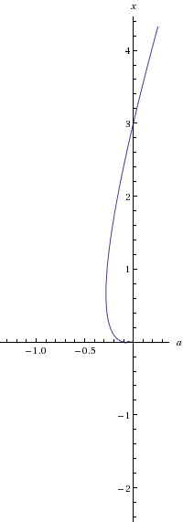

|  |  |  |  |  |  |
| --- | --- | --- | --- | --- | --- |
| а = | -0.28125 | -0.25 | -0.2 | -0.1 | 1 |
| х = | 0.65625 | 1.25 | 1.706226 | 2.404159 | 7.701562 |
| V(3x-a) = | 1.5 | 2 | 2.306226 | 2.704159 | 4.701562 |
| (x-3a) = | 1.5 | 2 | 2.306226 | 2.704159 | 4.701562 |