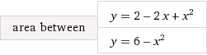

 integral_(-1)^2 (4+2 x-2 x^2) dx = 9

