' Cinderella, Inc.’

(a very probable story)
The girt.
(after Chris\
Kiue aooruav .. t. ^ ^{U1S extrcme,}y unattractive, hustled acrov She hurried »k ^ ^{a g,owin}« sign: Cinderella, Inc.
•din* near a hoicThk^ f i ^ ª"^{d Up lo a hand}«>mc ma She fumbled in her pockeitvw ^{serv,ce}» ^{m}adam,” he saic
^azinc. “Can the\ mat i ^{ug,lt oul a} Page tom out
"*** ^{me ,ook} Hkc that?” she demanded.

TEXT 3 # |
“Yes/' he said smiling, “hut it will he expensive.”
“Oh, I've got the money.”
The attendant took her to another room where a man in a white coat rose from his desk and ofTered her a chair facing him. His eyes went over her impersonally.
"What is it you want?” the man asked.
This, said the girl, and spread the picture before him.
He studied the picture for a minute, then looked the girl over again.
Stand up. please. She stood up. “Now turn around. Mm-hm... Well, sit down. He bridged his hands and looked at her. “I think we can do the body, but I m not sure of the lace. This will cost money. And we insist on a cash payment..”
How much money? she watched him tensely, opening her pocketbook. “One hundred thousand.”
She took out ten crisp bills and spread them on his desk. He nodded, scribbed a receipt, and led her out the door and down warm, gaily lighted perfumed halls to another hotel-like desk where two pretty young girls jumped to their feet to meet her. Automatically she showed them the receipt.
“Oh,” said one of the attendants, “you've already paid?”
“Yes.”
“Well, then we can forget about the sales talk.” They glanced at the receipt, and their eyes widened.
“You get the full treatment!” They looked envious.
“Don’t you think I need it?” she said coldly. “Why don’t we get started?” It was twenty days before she returned to consciousness, and it was thirty days after that before the doctors and attendants could be sure of the results. At last she stood in front of the mirror, naked, and saw what she had hoped for. Later she was called for her final interview.
“Please sit down,” said the woman doctor. She picked up a clinical photograph and showed it to the girl. “Do you recognize this woman?”
“Of course,” said the girl in her new sensuous voice, “That was I.”
“Now you’ll admit there’s been quite a change.”
“Of course.”
“It would be unpleasant to change back.”
There was a momentary silence. “Change back?”
“Yes, yes, I know,” said the doctor, “this sounds like a scene from a horror teleshow. But the fact is that the change was brought about, among other things, with the use of glandular secretions. A few chemicals were even used that don’t ordinarily exist in the adult human body. Now our doctors have


15
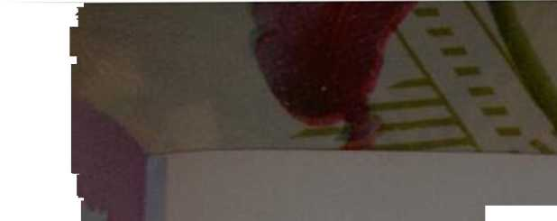


use a
*
^{as ihey b}“ *>“•"—» in thfbo“toVo?S„Vn_{e}^{C}T^^{red},^{PlaSti}‘^{: b}°^{X}- “^{The dir}“^{,i0}"^{s} ™
longer than len days wi,h„„f_{vo}“"Zf t¹'⁰? ^ ^{,hem Do}"'> *°
Td^{on ,haI S} ^
received a breath,airing smile i“reTum. ** ^{h}°^{W} *“ ^{,al}“^{ng} “ ^{She}
I m ofT, said the new beauty.
The wedding, three months later, was a striking one. The women stared enviously a, the tail handsome bridegroom, and the men watched the bridHS
n ^{8l},"^{e};^{>eS} r”': ^{lhe ceremony was over}-^{,he} couple occupied the bridal suite in a first-rate hotel for the night.
Darling, murmured the bride, “forgive me fora moment. I want to pretty up ” You re pretty enough to eat,” said the groom.
She laughed and slipped past him to the bathroom door with her travel case.
Once inside, she locked the door and brought out the little yellow plastic box!
She clicked open the cover and read the words inside, “Cinderella Inc. reminds you.”
“I remember,” she said, and began her ritual.
In the bedroom, the groom was in his shirt-sleeves whistling and unpacking his suitcase. Suddenly he stopped and stared at a little brown plastic box rolled up in his bathrobe.
TEXT 3


