Дано:

[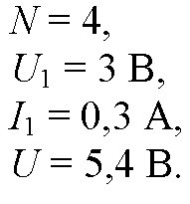](http://5terka.com/images/fiz10-11reshebnik/fiz10-11p7-342.jpg)

Найти R2.

Решение.

[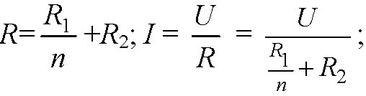](http://5terka.com/images/fiz10-11reshebnik/fiz10-11p7-343.jpg)[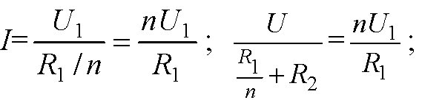](http://5terka.com/images/fiz10-11reshebnik/fiz10-11p7-344.jpg)[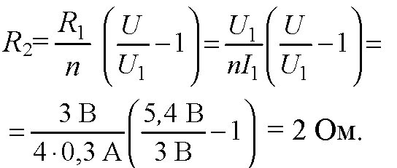](http://5terka.com/images/fiz10-11reshebnik/fiz10-11p7-345.jpg)

Ответ: R2 = 2 Ом.