$$y=\frac{{2x}^{3}-1}{x}+1$$
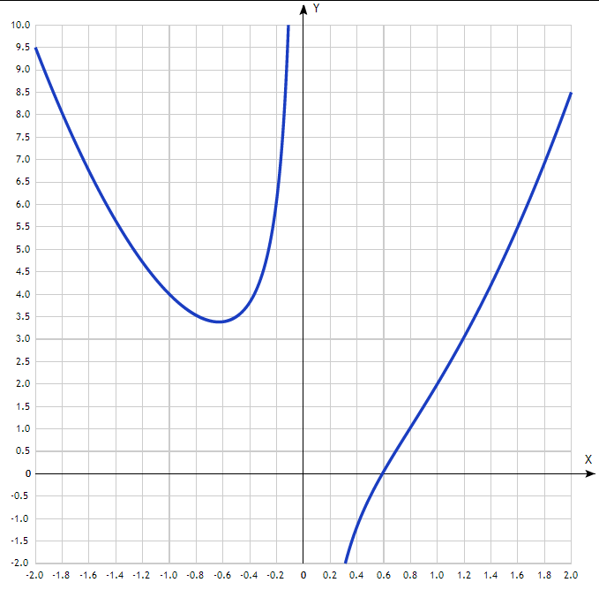

$$y=-x^{2}+x+8$$
