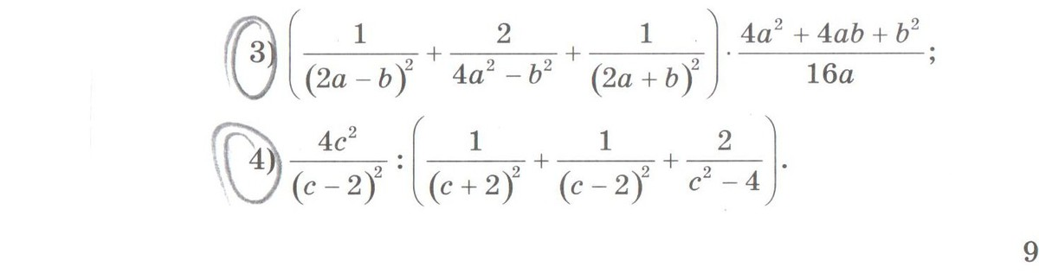
$$\begin{aligned}\left(\frac{1}{{\left(2a−b\right)}^{2}}+\frac{2}{4a^{2}−b^{2}}+\frac{1}{{\left(2a+b\right)}^{2}}\right)∗\frac{4a^{2}+4\text{ab}+b^{2}}{\text{16}a}=\left(\frac{1}{{\left(2a−b\right)}^{2}}+\frac{2}{\left(2a−b\right)\left(2a+b\right)}+\frac{1}{{\left(2a+b\right)}^{2}}\right)∗\frac{{\left(2a+b\right)}^{2}}{\text{16}a}= \\ \frac{{\left(2a+b\right)}^{2}+2\left(2a−b\right)\left(2a+b\right)+{\left(2a−b\right)}^{2}}{{\left(2a−b\right)}^{2}{\left(2a+b\right)}^{2}}∗\frac{{\left(2a+b\right)}^{2}}{\text{16}a}=\frac{{\left(\left(2a+b\right)+\left(2a−b\right)\right)}^{2}}{{\left(2a−b\right)}^{2}∗1}∗\frac{1}{\text{16}a}=\frac{\text{16}a^{2}}{{\left(2a−b\right)}^{2}}∗\frac{1}{\text{16}a}=\frac{a}{{\left(2a−b\right)}^{2}}\end{aligned}$$
$$\begin{aligned}\frac{4c^{2}}{{\left(c−2\right)}^{2}}:\left(\frac{1}{{\left(c+2\right)}^{2}}+\frac{1}{{\left(c−2\right)}^{2}}+\frac{2}{c^{2}−4}\right)=\frac{4c^{2}}{{\left(c−2\right)}^{2}}:\left(\frac{1}{{\left(c+2\right)}^{2}}+\frac{1}{{\left(c−2\right)}^{2}}+\frac{2}{(c−2)(c+2)}\right)= \\ \frac{4c^{2}}{{\left(c−2\right)}^{2}}:\left(\frac{{\left(c−2\right)}^{2}+{\left(c+2\right)}^{2}+2(c−2)(c+2)}{(c−2)^{2}(c+2)^{2}}\right)=\frac{4c^{2}}{{\left(c−2\right)}^{2}}:\left(\frac{{\left(\left(c−2\right)+\left(c+2\right)\right)}^{2}}{(c−2)^{2}(c+2)^{2}}\right)=\frac{4c^{2}}{{\left(c−2\right)}^{2}}∗\frac{(c−2)^{2}(c+2)^{2}}{{\left(2c\right)}^{2}}=(c+2)^{2}\end{aligned}$$

