y(x)=1/x

x | y
-5.0 | -0.2
-4.5 | -0.22
-4.0 | -0.25
-3.5 | -0.29
-3.0 | -0.33
-2.5 | -0.4
-2.0 | -0.5
-1.5 | -0.67
-1.0 | -1
-0.5 | -2
0 | -
0.5 | 2
1.0 | 1
1.5 | 0.67
2.0 | 0.5
2.5 | 0.4
3.0 | 0.33
3.5 | 0.29
4.0 | 0.25
4.5 | 0.22
5.0 | 0.2
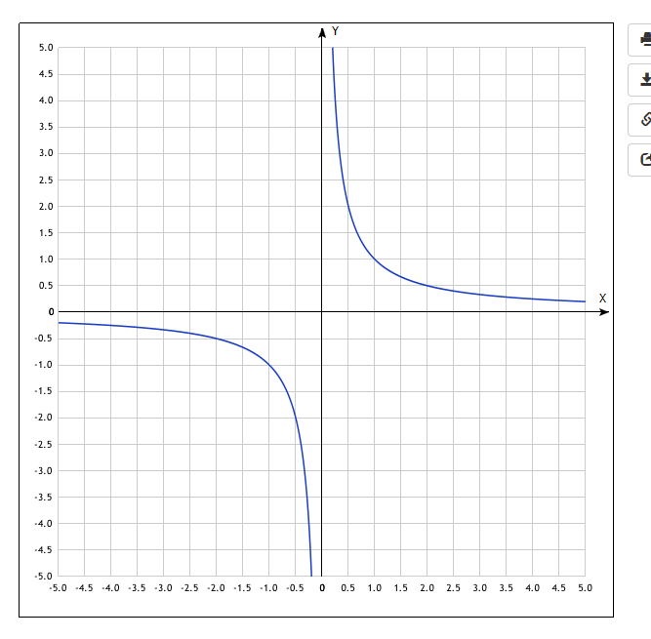
y(x)=2+1/x
x | y
-5.0 | 1.8
-4.5 | 1.78
-4.0 | 1.75
-3.5 | 1.71
-3.0 | 1.67
-2.5 | 1.6
-2.0 | 1.5
-1.5 | 1.33
-1.0 | 1
-0.5 | 0
0 | -
0.5 | 4
1.0 | 3
1.5 | 2.67
2.0 | 2.5
2.5 | 2.4
3.0 | 2.33
3.5 | 2.29
4.0 | 2.25
4.5 | 2.22
5.0 | 2.2

Наша группа Вконтакте - присоед
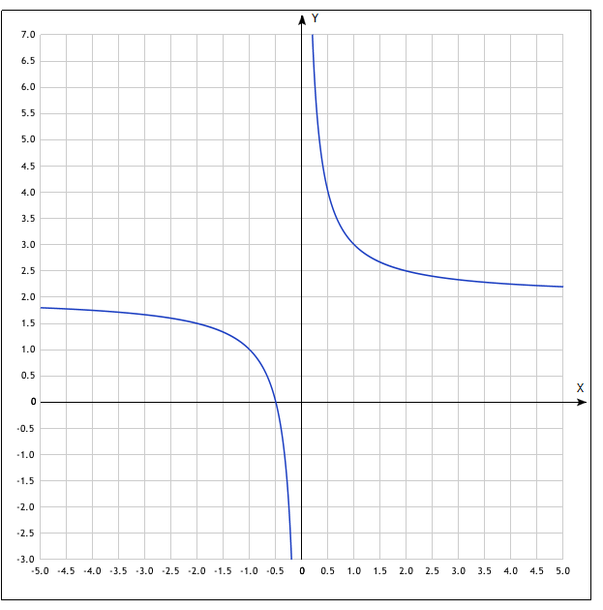
y(x)=−3+1/x
x | y
-5.0 | -3.2
-4.5 | -3.22
-4.0 | -3.25
-3.5 | -3.29
-3.0 | -3.33
-2.5 | -3.4
-2.0 | -3.5
-1.5 | -3.67
-1.0 | -4
-0.5 | -5
0 | -
0.5 | -1
1.0 | -2
1.5 | -2.33
2.0 | -2.5
2.5 | -2.6
3.0 | -2.67
3.5 | -2.71
4.0 | -2.75
4.5 | -2.78
5.0 | -2.8
