y(x)=2(sin(x/2))2−2(cos(x/2))2

[Показать таблицу точек](javascript:void(0);)

|  |  |
| --- | --- |
| **x** | **y** |
| -4.0 | 1.31 |
| -3.5 | 1.87 |
| -3.0 | 1.98 |
| -2.5 | 1.6 |
| -2.0 | 0.83 |
| -1.5 | -0.14 |
| -1.0 | -1.08 |
| -0.5 | -1.76 |
| 0 | -2 |
| 0.5 | -1.76 |
| 1.0 | -1.08 |
| 1.5 | -0.14 |
| 2.0 | 0.83 |
| 2.5 | 1.6 |
| 3.0 | 1.98 |
| 3.5 | 1.87 |
| 4.0 | 1.31 |

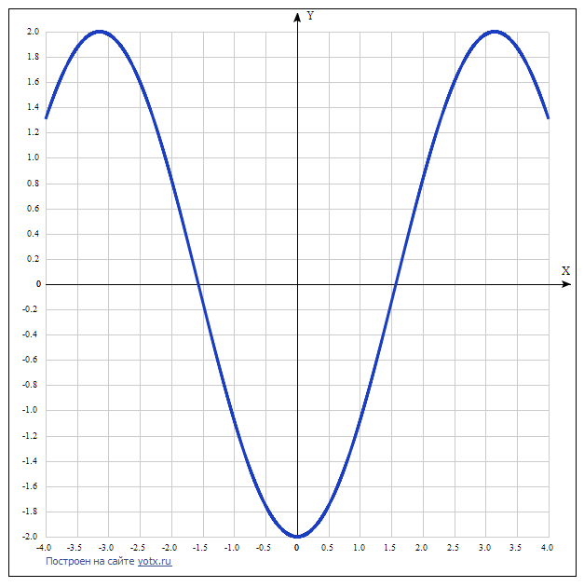

y(x)=abs(cos(2x))−1

[Показать таблицу точек](javascript:void(0);)

|  |  |
| --- | --- |
| **x** | **y** |
| -4.0 | -0.854 |
| -3.5 | -0.246 |
| -3.0 | -0.04 |
| -2.5 | -0.716 |
| -2.0 | -0.346 |
| -1.5 | -0.01 |
| -1.0 | -0.584 |
| -0.5 | -0.46 |
| 0 | 0 |
| 0.5 | -0.46 |
| 1.0 | -0.584 |
| 1.5 | -0.01 |
| 2.0 | -0.346 |
| 2.5 | -0.716 |
| 3.0 | -0.04 |
| 3.5 | -0.246 |
| 4.0 | -0.854 |

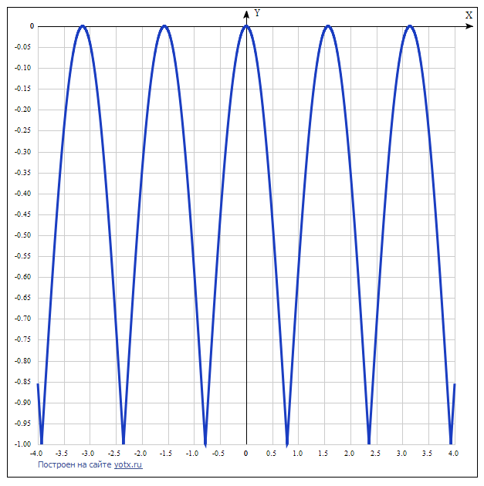

y(x)=2sin(x)+1

[Показать таблицу точек](javascript:void(0);)

|  |  |
| --- | --- |
| **x** | **y** |
| -4.0 | 2.51 |
| -3.5 | 1.7 |
| -3.0 | 0.72 |
| -2.5 | -0.2 |
| -2.0 | -0.82 |
| -1.5 | -0.99 |
| -1.0 | -0.68 |
| -0.5 | 0.04 |
| 0 | 1 |
| 0.5 | 1.96 |
| 1.0 | 2.68 |
| 1.5 | 2.99 |
| 2.0 | 2.82 |
| 2.5 | 2.2 |
| 3.0 | 1.28 |
| 3.5 | 0.3 |
| 4.0 | -0.51 |

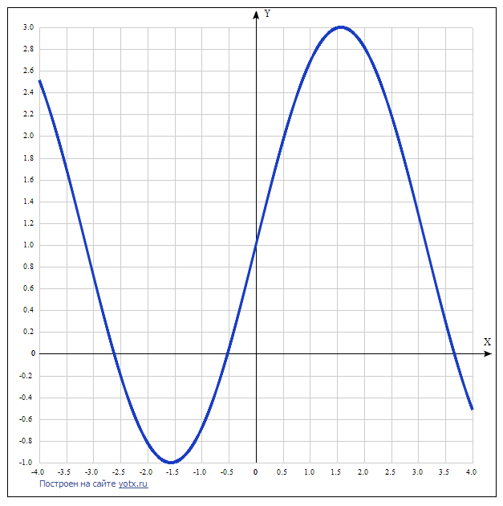

y(x)=sin(2x)/abs(cos(x))

[Показать таблицу точек](javascript:void(0);)

|  |  |
| --- | --- |
| **x** | **y** |
| -4.0 | -1.51 |
| -3.5 | -0.7 |
| -3.0 | 0.28 |
| -2.5 | 1.2 |
| -2.0 | 1.82 |
| -1.5 | -1.99 |
| -1.0 | -1.68 |
| -0.5 | -0.96 |
| 0 | 0 |
| 0.5 | 0.96 |
| 1.0 | 1.68 |
| 1.5 | 1.99 |
| 2.0 | -1.82 |
| 2.5 | -1.2 |
| 3.0 | -0.28 |
| 3.5 | 0.7 |
| 4.0 | 1.51 |

