https://znanija.com/task/24810840 y=x³-2x²-4x
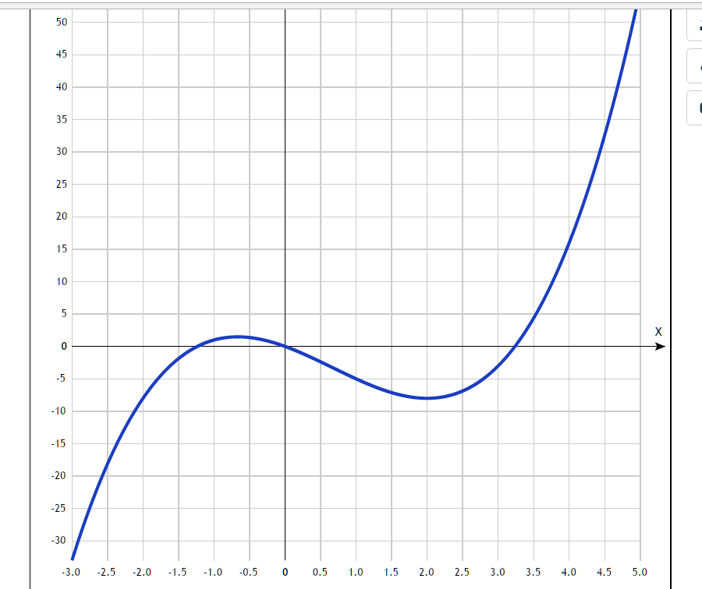
Таблица точек

x | y
-3.0 | -33
-2.5 | -18.1
-2.0 | -8
-1.5 | -1.9
-1.0 | 1
-0.5 | 1.4
0 | 0
0.5 | -2.4
1.0 | -5
1.5 | -7.1
2.0 | -8
2.5 | -6.9
3.0 | -3
3.5 | 4.4
4.0 | 16
4.5 | 32.6
5.0 | 55

