Name: Karolina
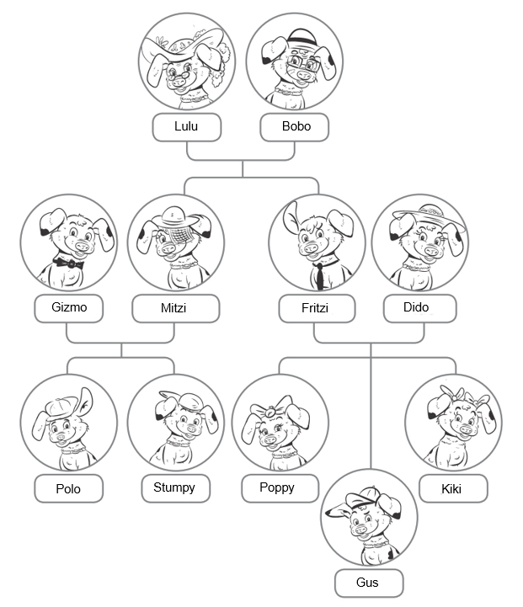

Class: 5-A

VOCABULARY
1 Look at the family tree and complete the sentences.
0 Lulu is Gus’s grandmother.
1 Mitzi is Poppy’s aunt .
2 Gizmo is Kiki’s uncle .
3 Polo is Stumpy’s brother .
4 Mitzi is Bobo’s daughter .
5 Gus is Dido’s son .
6 Stumpy is Poppy’s cousin .
7 Bobo is Kiki’s granny .
8 Kikki is Poppy’s sister .
/8

2 Complete the sentences with the words in the box. There is one extra word.
American at China on park Poland Polish school UK
Wu and Chen are from ⁰China. They’re Chinese. They’re in the ¹ .
Jane is British. She’s from the ² . She’s ³ holiday.
Mark is from the USA. He’s ⁴ . He’s at ⁵ .
Dorota is from ⁶ . She’s ⁷ home.
/7


3 Circle the correct words.

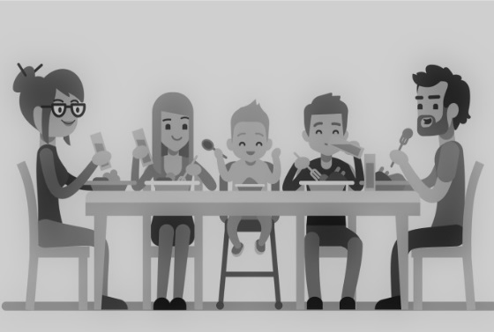

Look at this⁰painting / photo. It is ¹the / by Hank Adams. He is an American ² artist / picture. The ³children / people in the picture are Mr and Mrs Cole, Lola, Ollie and Jojo. It’s my favourite ⁴picture / artist!
/4

GRAMMAR
4 Complete the sentences. Write the correct positive [✓] or negative [✗] form of to be.
0 My best friend isn’t Spanish. ✗
0 My best friend is from Poland. ✓
1 I isn’t eleven years old. ✗
2 We are American. ✓
3 You and your family aren’t British. ✗
4 Enzo and Maria are Italian. ✓
5 Luisa’s mum isn’t a teacher. ✗
6 The man in the photo is my dad. ✓
7 I am at Granny’s house. ✓
8 Paul and I aren’t students. ✗
/8

5 Complete the sentences with my or your.
0 I’m a student. My mum is a teacher.
1 It’s your birthday today. Happy birthday, Sue!
2 I’m Turkish. My parents are Turkish too.
3 You’re from the UK. Your nationality is British.
4 I’m here with my cousins.
/4

6 Look at the family tree in Exercise 1. Write sentences with possessive ’s.
0 Fritzi dad Bobo is Fritzi’s dad.
1 Gus mum Dido is Gus’es mum
2 Stumpy brother Polo is Stumpy’s brother
3 Lulu daughter Mitzi is Lulu’s daugther
4 Polo parents Mitzi and Gizmo are Polo’s parents.
/4

COMMUNICATION
7 Match 1-5 to a-f to make a dialogue.
Sam: 0 c
1 e
2 f
Dad: 3 b
4 d
Gordon: 5 a

a Nice to meet you, too, Mr Brown.
b Hello, Gordon.
c Dad, this is Gordon.
d Nice to meet you.
e He’s my classmate.
f Gordon, this is my dad.
/5

Vocabulary / 19
Grammar / 16
Communication / 5
Your total score / 40

