
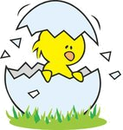
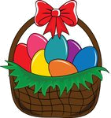

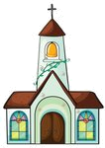
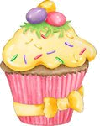
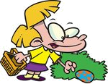
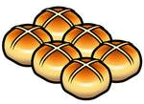
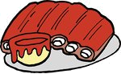
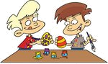
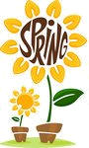
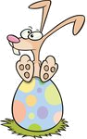

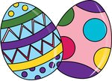
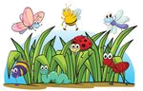
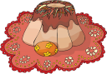
Are the statements true (✓), false (✗) or doesn’t it say (∅)?
1 Easter is in summer.
2 Easter starts two days before Sunday.
3 Everybody eats hot cross buns on Good Friday in Britain.
4 Jack’s family eats hot cross buns on Good Friday morning.
5 Children make Easter bonnets this year at school.
6 Jack likes doing Easter projects.
7 Easter egg hunting means that children eat chocolate eggs.
8 Jack gets three chocolate eggs.
9 On Sunday afternoon two cousins come over.
10 Unfortunately, children have to go to school at Easter in Britain.
Answer the questions.

1 When is Easter?
_________________________________
2 What do people celebrate at Easter? _________________________________
3 Who gets chocolate eggs in Britain? _________________________________
4 What are the traditional food at Easter?
_________________________________
5 Why does Jack like Easter?
_________________________________

Complete the sentences.
1 This year the Easter project will be a ____________________ full of painted eggs.
2 After ______________ Jack’s family goes to church.
3 Emily and Jack ______________ Easter eggs in the garden.
4 In the __________ all his family have tea.
5 At Easter _________________ no school in Britain.
What about you? How do you celebrate Easter? What do you do at Easter? What do you eat? Do you have Easter holidays in you country?

Hello Friends! My name’s Jack.
I’m 12 years old and I live
in a small town in the south of
Britain with my mum, dad and
my sister, Emily.
Spring is here now and I’m very happy because of it. But now, I would like to tell you what we do in Britain at Easter.
Easter is in spring and people celebrate the resurrection of Jesus Christ. Easter starts on Good Friday in Britain. My mum makes hot cross buns and we eat them for tea. We usually have Easter-projects at school. Last year we made colourful hats, called Easter bonnets. This year we are going to design a basket full of painted Easter eggs. It will be a great fun!
On Easter Sunday morning we have a big breakfast. After breakfast we all go to church. When we get home, we give each other chocolate eggs. (Kids get the biggest ones!) Then we play ‘Easter egg hunt”. My parents hide some Easter eggs in the garden and Emily and I look for them. We love playing it.
We have roasted lamb with veggies for lunch.
In the afternoon my cousins, aunts and uncles come over for tea. We have Easter cupcakes, cakes and delicious tea. After tea we usually go for a walk together.
I like Easter because it is a great family festival and there is no school for two weeks!:)
OUR EASTER
Match the words to the pictures.
1 church
2 egg hunting
3 spring
4 hot cross buns
5 chocolate egg
6 garden
7 cupcake
8 chick
9 bunny
10 roasted lamb
11 egg painting
12 basket
13 Easter eggs
14 cake
15 bonnets

