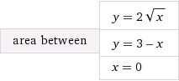

http://www4a.wolframalpha.com/Calculate/MSP/MSP108341ha57h7d9d4fi1620000626gif597bbgae5a?MSPStoreType=image/gif&s=10&w=240.&h=36.

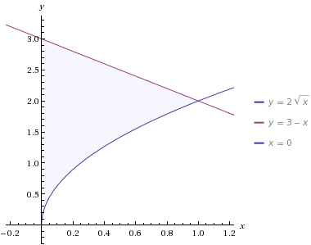

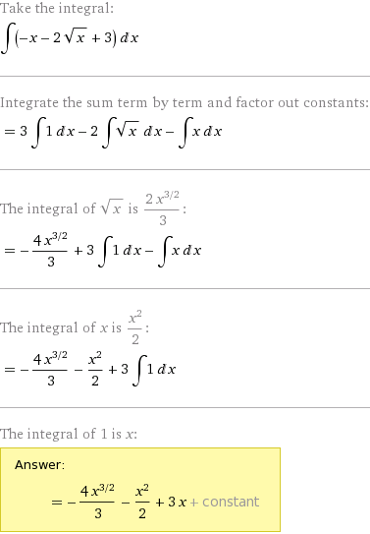

Подставив пределы, получим:

S = -4\*1/3-1/2+3\*1 -0 = -4/3-1/2+3 = -11/6+18/6 = 7/6.