http://www5b.wolframalpha.com/Calculate/MSP/MSP28801cha5e23872c2id9000047i33409b6hc0cf5?MSPStoreType=image/gif&s=40&w=157.&h=35.

*x2 = 9*

http://www5b.wolframalpha.com/Calculate/MSP/MSP28851cha5e23872c2id900005858ida88143934c?MSPStoreType=image/gif&s=40&w=47.&h=18.

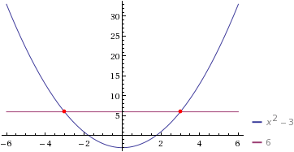

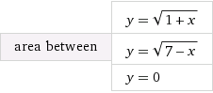

http://www4c.wolframalpha.com/Calculate/MSP/MSP96031g6d291ab8ia7bcg0000625dfgahf0g2c9ec?MSPStoreType=image/gif&s=63&w=315.&h=36.

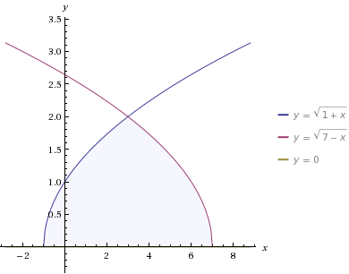

 integral_(-1)^3 sqrt(1+x) dx = 16\/3 ~~ 5.3333

 integral sqrt(1+x) dx = 2\/3 (x+1)^(3\/2)+constant

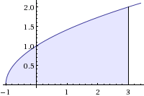

 integral sqrt(7-x) dx = -2\/3 (7-x)^(3\/2)+constant

 integral_3^7 sqrt(7-x) dx = 16\/3 ~~ 5.3333