y(x)=x2/(x2+2x+3)

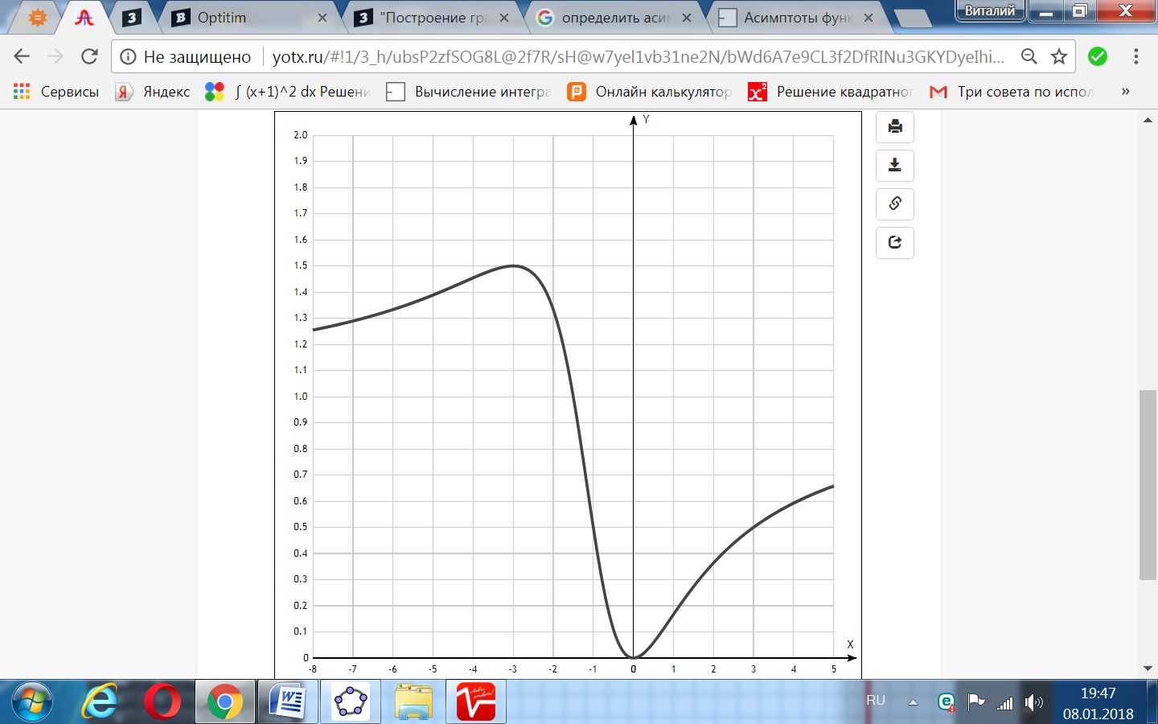

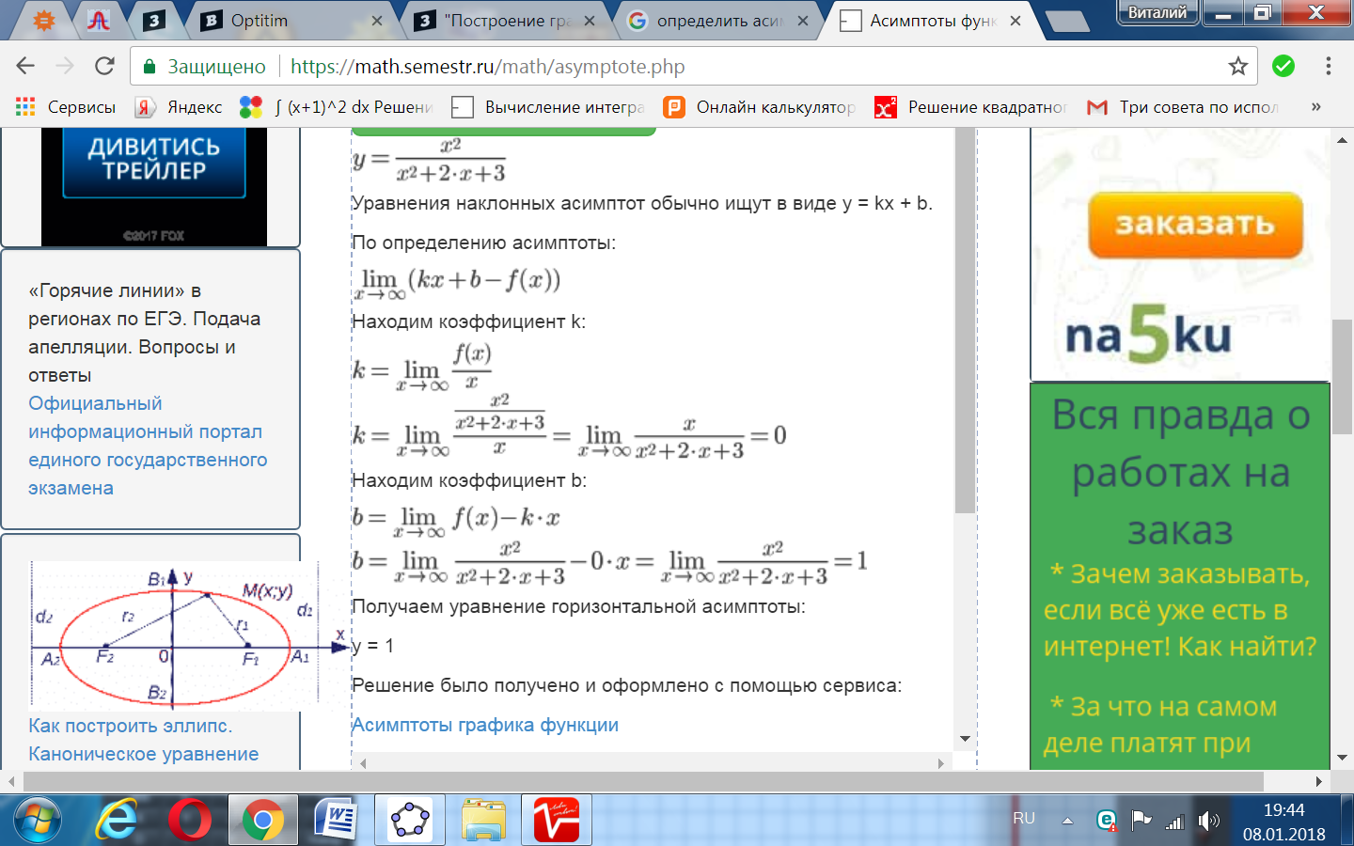

[Таблица точек](javascript:void(0);)

|  |  |
| --- | --- |
| **x** | **y** |
| -8 | 1.25 |
| -7 | 1.29 |
| -6 | 1.33 |
| -5 | 1.39 |
| -4 | 1.45 |
| -3 | 1.5 |
| -2 | 1.33 |
| -1 | 0.5 |
| 0 | 0 |
| 1 | 0.17 |
| 2 | 0.36 |
| 3 | 0.5 |
| 4 | 0.59 |
| 5 | 0.66 |