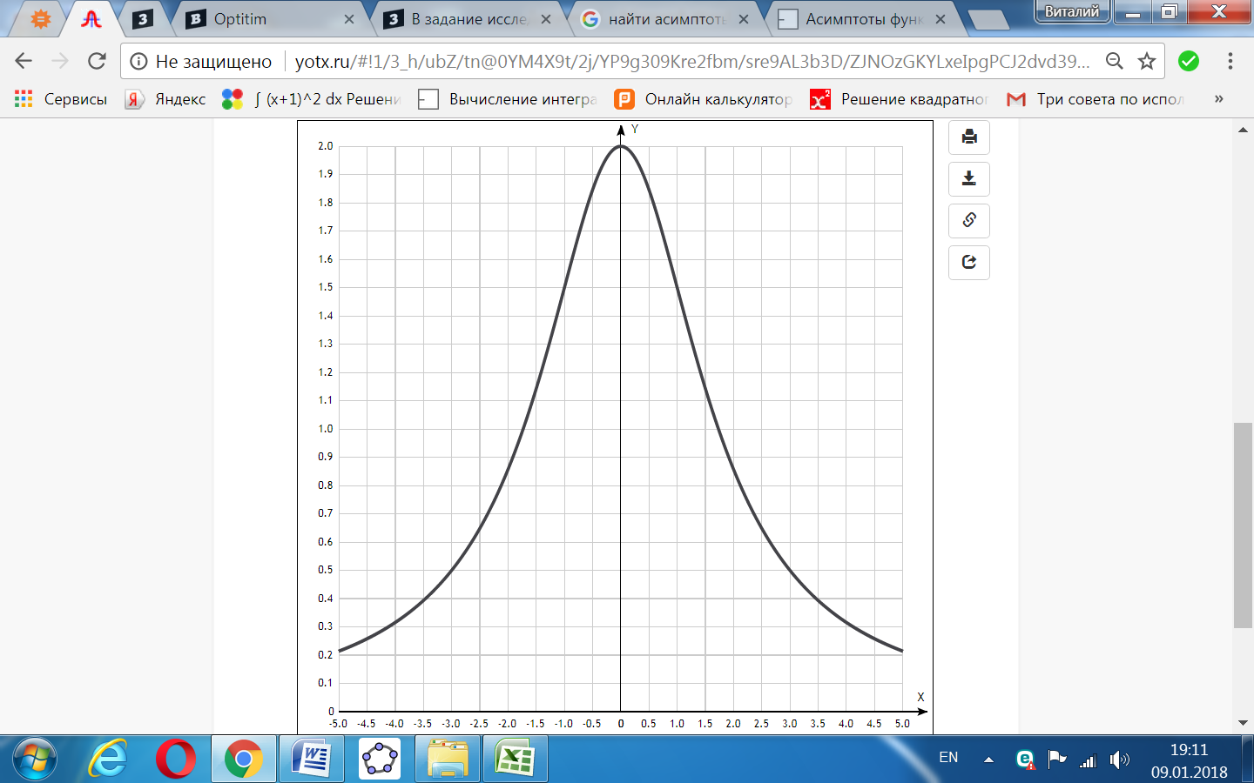

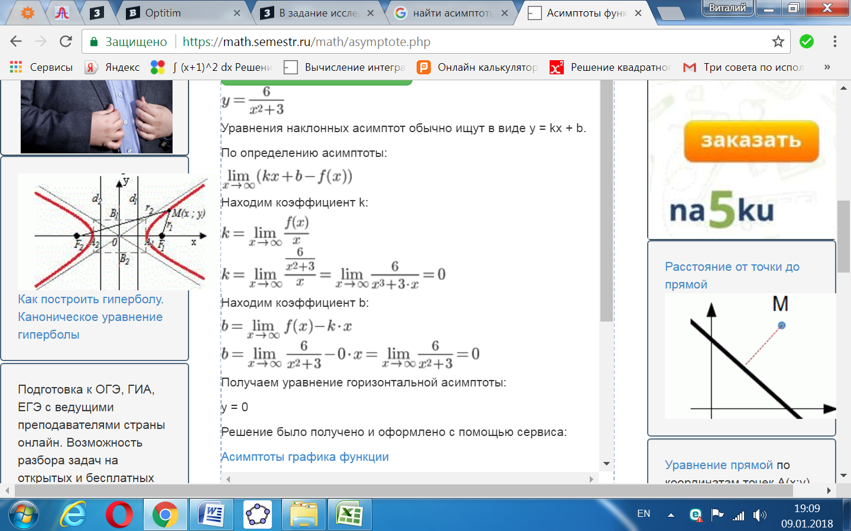

[Таблица точек](javascript:void(0);)

|  |  |
| --- | --- |
| **x** | **y** |
| -5.0 | 0.21 |
| -4.5 | 0.26 |
| -4.0 | 0.32 |
| -3.5 | 0.39 |
| -3.0 | 0.5 |
| -2.5 | 0.65 |
| -2.0 | 0.86 |
| -1.5 | 1.14 |
| -1.0 | 1.5 |
| -0.5 | 1.85 |
| 0 | 2 |
| 0.5 | 1.85 |
| 1.0 | 1.5 |
| 1.5 | 1.14 |
| 2.0 | 0.86 |
| 2.5 | 0.65 |
| 3.0 | 0.5 |
| 3.5 | 0.39 |
| 4.0 | 0.32 |
| 4.5 | 0.26 |
| 5.0 | 0.21 |