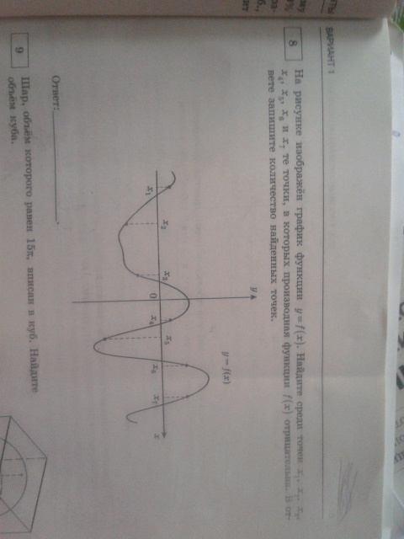

f’(x)<0

f’(x)<0

f’(x)<0