**Reading Test, 6th**

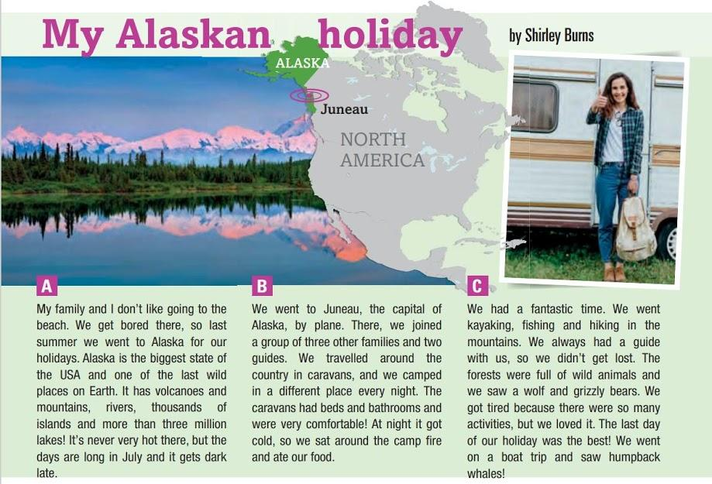

**Ex. 1. Read the text. Match paragraphs A, B, C to the headings 1 – 4. There is ONE EXTRA heading.**

1. A dangerous place.
2. Life on the road.
3. An unusual place for a holiday.
4. Not a holiday for lazy people!

**Ex. 2. Read the text again. Which paragraph A,B or C:**

1. Which paragraph mentions the name of a city?
2. Which paragraph mentions very big numbers?
3. Which paragraph describes Shirley’s favourite part of the holiday?
4. Which paragraph says how Shirley travelled around Alaska?
5. Which paragraph says why Shirley and her family went to Alaska?
6. Which paragraph mentions the animals Shirley saw?

**Ex. 3. True or False?**

1. Shirley enjoys going to the beach.
2. Alaska is a part of the USA.
3. Alaska is one of the last big islands on Earth.
4. It can be very hot in Alaska in July.
5. Shirley’s family went to Juneau in a caravan.
6. At night they ate outside the caravan.
7. They had a guide, so they sometimes got lost.

**Ex. 4. Choose the right answer.**

1. Is Alaska the biggest state of the USA?
2. Yes b) No c) We dont’t know

2) Does it get dark late in June?

1. Yes b) No c) We dont’t know

3) How many families travelled together?

1. Two b) Three 4) Four

4) What was there in the caravans?

1. bathrooms and beds b) kitchens and bedrooms

c) beds and a campfire

5) Why did they get tired?

1. Because at night it got cold. b) Because they had a lot of activities.

c) Because they went on a boat trip.

6) What animals did they see on the last day of the trip?

1. grizzly bears b) humpback whales c) a wolf

**Використані матеріали:** Підручник GoGetter 3, Pearson.