******The world of Mass Media**

* 1. **Films and TV programmes**

**I *can talk and write about films and TV programmes***

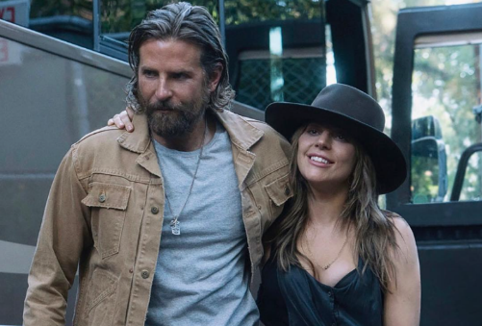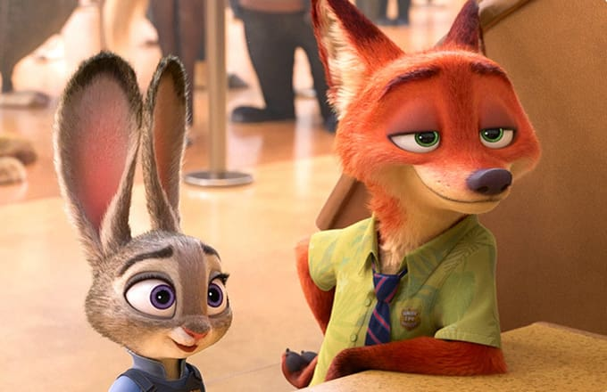 1a **Speaking & Vocabulary** **Look at the photos A-F. Do you know any of these films or TV programmes? Can you name any of the actors or characters? Why are they famous? What have they done to be famous?**

C

A

B

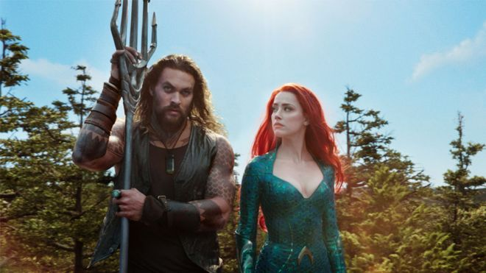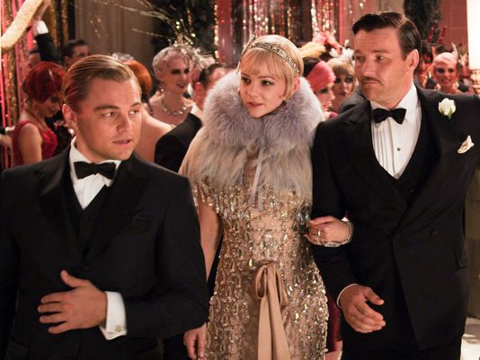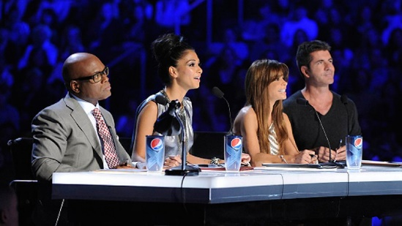

F

E

D

1b **What are your favourite kinds of films/TV programmes? Match out of the words below with photos A-F.**

Action film, animation, chat show, comedy, documentary, fantasy film, game show, horror film, musical, comedy, documentary, reality show, romantic comedy, sci-fi film, drama television series, soap opera, talent show, thriller, war film, western, biopic.

2a **Work in pairs. Talk about which types of films and TV programmes and films you and your partner like and dislike. Give reasons using the adjectives below.**

boring, confusing, convincing, embarrassing, exciting, funny, gripping, imaginative, interesting, moving, scary, spectacular, unrealistic, violent, dull, predictable, entertaining, spectacular.

* In my opinion, horror films are really exciting. What about you?
* To tell the truth, I am not a fan of horror films. They`re really violent. But I like …

2b **Choose an adjective that best describes the film the people are talking about in sentences 1-7.**

1 I knew exactly what was going to happen at the end.

2 I have never been so bored in my life!

3 The story was fantastic. I couldn’t take my eyes off the screen from start to finish.

4 We were all crying when we came out of the cinema.

5 There were too many laughs, but it really made me think.

6 There was too much fighting and blood!

7 The photography and the special effects were amazing.

**3b Work in pairs. Choose any film that you have recently watched and describe the plot using the adjectives in exercise 2a.**

Reading & Writing a film review

**4a You are going to read a review of the classic American film, The Great Gatsby, based on a book by F. Scott Fitzgerald. What information do you expect to find in the review?**

**4b Compare your ideas with a-e below.**

**a** the writer`s opinion **b** the plot/storyline **c** the name of the director

**d** who stars in the film **e** whether the book is better than the film

**4c Read the review and match the information from the review (a-e) to the paragraph it is in.**

Paragraph 1 ____________________ Paragraph 3 ____________________

Paragraph 2 ____________________ Paragraph 4 ____________________

**The Best Film of All Time?**

**What is your favourite film of all time? We are inviting fans to post review. Then you can vote for your favourite.**

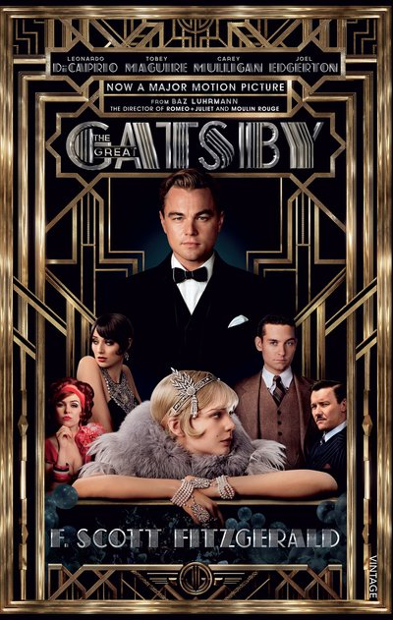

**1** The Great Gatsby was directed by Baz Luhrmann and is based on a novel by F. Scott Fitzgerald. Starring Tobey Maguire and Leonardo DiCaprio, the film is surprisingly positive in places, but is essentially, it is sad story about love and destiny of human. Despite failing at the box office when it was originally released in 2013, it has now become a modern classic.

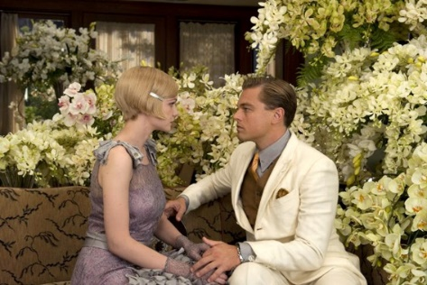**2** The film is set in the 20s in the USA. Midwest native Nick Caraway (Tobey Maguire) arrives in 1922 New York in search of the American dream. Nick, a would-be writer, moves in next-door to millionaire Jay Gatsby (Leonardo DiCaprio) and across the bay from his cousin Daisy (Carey Mulligan) and her philandering husband, Tom (Joel Edgerton). Thus, Nick becomes drawn into the captivating world of the wealthy and - as he bears witness to their illusions and deceits -pens a tale of impossible love, dreams, and tragedy.

**3** Luhrmann makes few changes to Fitzgerald’s original novel, and manages to make the end result even more exciting than the book. Lana Del Rey`s song «Young and Beautiful» creates an exciting atmosphere throughout the film.

**4** The Great Gatsby is terrific entertainment. Leonardo DiCaprio’s performance is very moving, and Carey Mulligan gives one of her best performance of her career. Although the film is a little slow in places, the end is absolutely brilliant and I highly recommend it to everyone.



**5a Read the information about contrast linkers. We use the following linkers to show that things are different.**

**Although/Even though -** Although I don’t like action films, I loved this one.

**Despite/In spite of -** Despite seeing the film twice, I still didn’t understand the ending.

**However -** However, I loved the rest of the film.

**5b Underline the linkers and what follows them in the review.**

**5c Make up 5 sentences using the contrast linkers.**

**TASK Think about a film you have recently enjoyed. Make notes on the film using the points from the exercise 1b and the language in exercise 3a. Write a review of the film. Answer the following questions while writing:**

1. What is the title of the film?
2. What genre is it?
3. What is it about?
4. Is it based on a book?
5. Where is the film set?
6. When is the film set?
7. Who stars in the film?
8. Who plays the main role(s)?
9. Who is your favourite character in the film? (Why?)

10. What kind of person would like this film?

6a Listening & Pronunciation **You are going to listen the soundtrack Young and Beautiful to the film The Great Gatsby by Lana Del Rey. Before listening discuss the following questions:**

1 What do you think the song about? Explain why.

1. What is the singer famous for? Did you listen any songs of hers?
2. Look at the pictures and try to guess what is the song about?

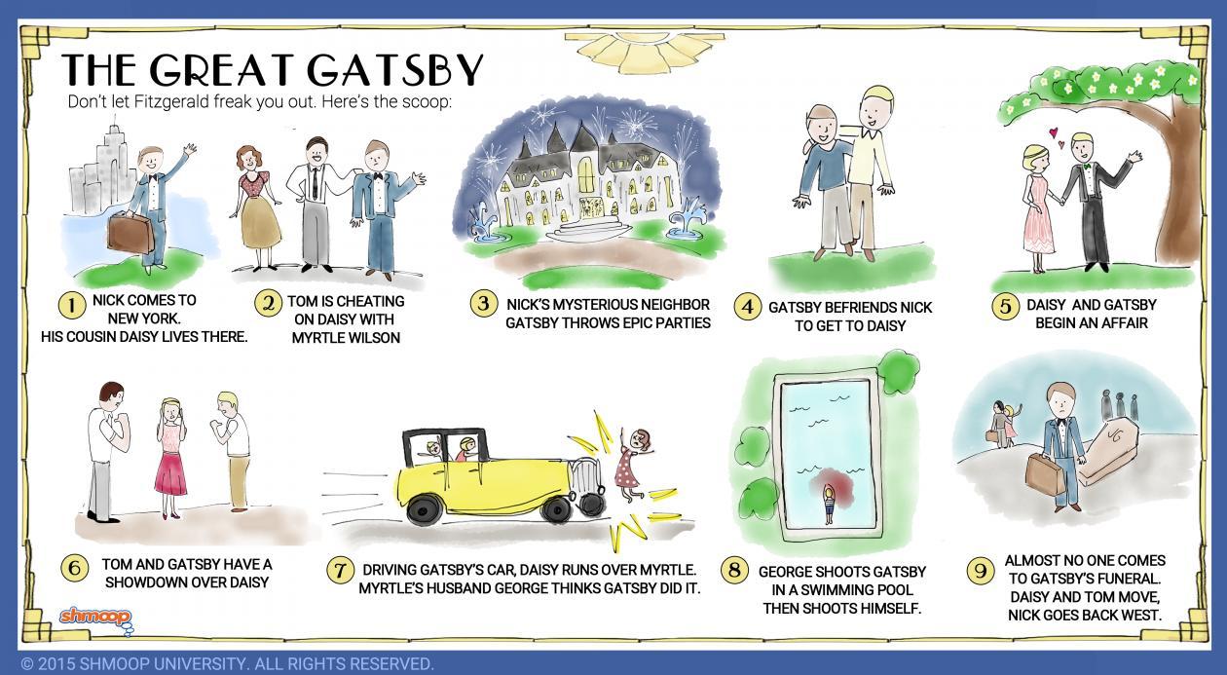



6b **Listen to the song and fill in the missing gaps.**

Young and Beautiful

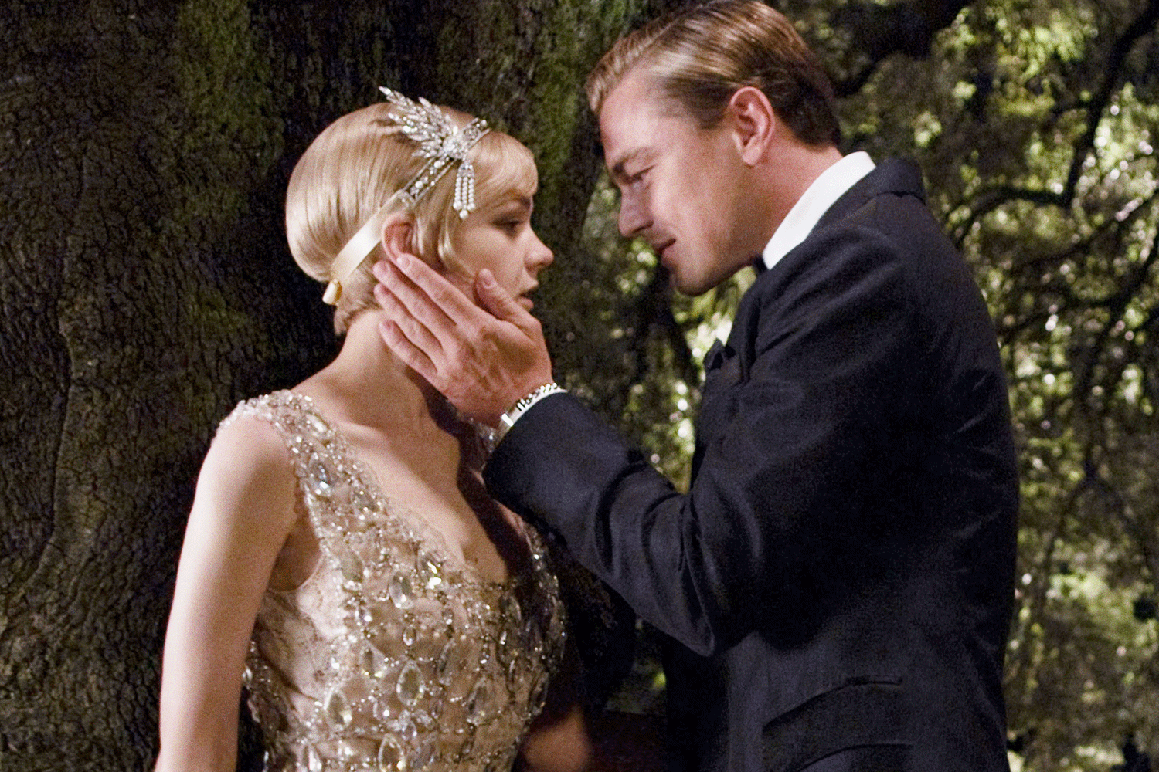

I've seen the __________, done it all  
Had my cake now  
Diamonds, brilliant, and Bel Air now  
Hot summer **nights**, mid-July  
When you and I were _________ wild  
The crazy days, city **lights**  
The way you **would** play with me like a child

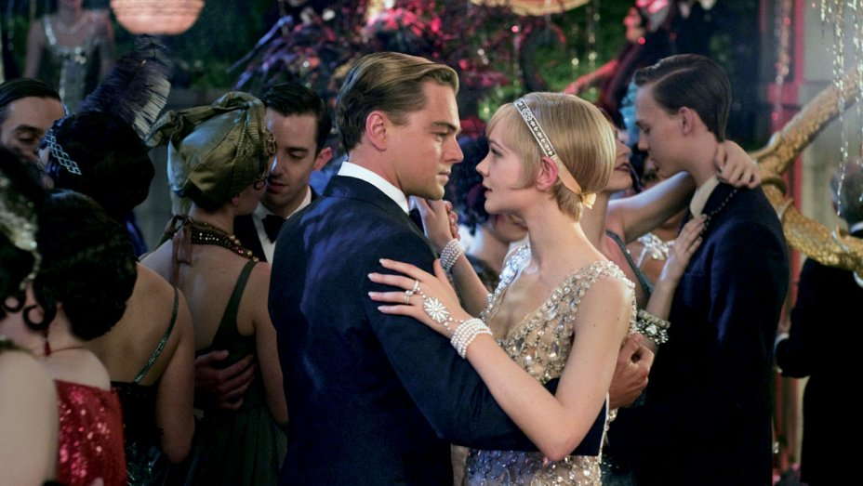Will you still love me when I'm no _________ young and beautiful?  
Will you still love me when I got nothing but my aching soul?

I **know** you will, I **know** you will  
I **know** that you will  
Will you still love me when I'm no ________ beautiful

I've seen the world, lit it up as my **stage** now  
Channeling angels in the new **age** now  
Hot _________ days, rock and roll  
The way you'd play for me at your show  
And ________ the ways I got to know

Your pretty face and electric ________

6c **Answer the questions:**

**1 Which words in bold in the song have the silent letters?**

**2 What are the silent letters in these words:** doubt, castle, hour, knowledge, two, sign, change, tongue, muscle, autumn, daughter.

3 **Read the rule and underline the correct option:**

A **silent letter** is a **letter** that, in a particular word*, does not/ does* correspond to any sound in the word's pronunciation. One of the noted difficulties of **English** spelling is a *high/small* number of **silent letters**, they make the spelling of words *different/similar* from their pronunciation.

7a **Read the grammar rule.**

***No longer*, *not any longer***

We use *no longer* or *not any longer* to talk about the end of an action or state.  Will you still love me when I am **no longer** young and beautiful?

*Compare:*

She **no longer** works here. She **doesn’t** work here **any longer**. (She isn’t working here now.)

8a **Make up 5 sentences using no longer, not any longer.**



**Home Project Find out the film that you will think will be interesting to discuss in class. Write a film review and make a ppt.**

**TEACHER’S BOOK**

**THE WORLD OF MASSMEDIA  
1.1 FILMS AND TV PROGRAMMES**

**Unit 1,1 Lesson Plan**

**Level:** Intermediate (CEFR B1,B2)

**Age group:** Teenagers, Adults **Time:** 80 minutes **Number of students:** 10-12

**Mode of interaction:** the whole group (T-Ss), pair-work (S-S), group work (Ss-Ss)

**Aim:**

* To develop students’ writing skills.

**Objectives:**

* To train students to use Film and TV programmes vocabulary;
* To develop students’ critical thinking;
* To develop students’ reading, speaking, listening, and writing skills;
* To train students to practice grammar.

**Materials:** Handouts, board, marker, TV-set, laptop

**Procedure:**

**Greeting/Checking students` attendance (5 minutes)**

**Warm-up (10 min) TV programmes Quiz**

**Mode of interaction:** two groups (T-Ss)

* Tell students that they are going to be involved in the TV shows quiz. Divide your class into two teams and ask students to name their teams. Show them a video and give points to those team who can guess what is a TV-program. Encourage students to use English as much as possible. Help students with weaker knowledge if it is necessary by giving them hints.

Answers: Culinary program, Talk-show, Game show, Quiz show, Music clip< weather forecast, News, film, sitcom, soap opera.

**Pre-stage (10 minutes)**

**Mode of interaction**: the whole group (T-Ss), small groups (Ss-Ss)

* 1a Speaking & Vocabulary: Tell students to look at the pictures in exercise 1a and ask them to guess what films and TV programmes are in the photos. Elicit answer by giving hints to your students. Ask students to explain why these people are famous and what they have done to be famous.

Answers: Focus attention on the pictures and ask your students whether they know any of these films/TV programmes.

Answers: A – Zootopia, B – A Star is Born, C – The Game of Thrones, D – Aquaman, E – The Great Gatsby, F – American X-factor

Help students if it is necessary. Continue to discuss the questions: Can you name any of the actors or characters:

Answers: A – Judi Hopes, Nick Wild; B – David Bradley Cooper (Jackson Maine), Lady Gaga (Ally), C - Emilia Clark (Daenerys Targaryen), Kit Harington ( John Snow), D – Jason Momoa (Aqua man), Amber Heard (Mera); F – Simon Cowell and others.

* 1b Ask students to work in pairs and look at the vocabulary in exercise 1b. Tell them to recall the vocabulary and ask them to use it when they answer the questions. With weaker classes, make them work with a dictionary and ask them to make flashcards for the next lesson. Tell your students that they have to match out the words in the exercise with the photos A-F. There is vocabulary which is useful to talk about the genres of films.

Answers: A – animation; B – drama; C – drama television series; D – fantasy, adventure; E – drama, romance; F – reality/talent show

* 2a Ask students to read the instructions in exercise 2a. Ask them work in pairs and discuss the adjectives to describe films. If it is necessary, choose one student and show the example of how to interview each other. Encourage students to use new vocabulary as much as possible.
* 2b Ask student to do the exercise to test their knowledge of new adjectives. Give them limited time and check the answers. Ask students to learn new vocabulary and prepare for the quiz next lesson.

Answers: 1. Predictable, 2. Dull, 3. Spectacular, 4. Moving, 5. Violent, 6. Entertaining.

**While-stage (30 minutes)**

**Mode of interaction: pair work (S-S), individual work (S)**

* Reading Writing. Ask students to read the instructions in exercise 4a. Elicit the answers.

Possible answers: I want to read a movie review which will make me exciting about watching a film. I think that it will be very interesting to read.

*Cultural Note for teachers*: The Great Gatsby is a 2013 romantic drama film based on F. Scott Fitzgerald's 1925 novel of the same name. ... The film follows the life and times of millionaire Jay Gatsby (DiCaprio) and his neighbor Nick Carraway (Maguire), who recounts his encounter with Gatsby at the height of the Roaring Twenties on Long Island.

* Tell Students that they are going to work in pairs. Their task is to read the film review and match the information from review (a-e) to the paragraph it is in. Give them limited time and ask them to check their answers in pairs.

Answers: 1 c,d ; 2 b; 3 e; 4 a.

* Discuss the structure of a film review with students. Make them understand what dos and don’ts of writing a film review.
* Tell students to look at exercise 5a, where they are going to learn the contrast linkers such as Although/Even though, Despite/In spite of, However. Write as many examples as possible on the board.
* Ask your students to underline the examples in the review. Help weaker students if it is necessary. Then, ask students to make up their own sentences to fix the knowledge of the grammar. Ask them to work in pairs to check the sentences for mistakes.
* Task: ask your students to think of any movie they have recently watched and ask them to write a film review using guidelines for writing. Then collect the reviews and check their answers. Pay special attention to the structure, new vocabulary and grammar.

**Post-stage (20 minutes)**

**Mode of interaction: pair work (S-S)**

* Listening and Pronunciation. Ask students to work in pairs and answer the questions in exercise 6a. Elicit the answers by helping students to use new adjectives to describe film. Encourage students’ critical thinking.
* Ask students to look at the exercise 6b. Tell them that they are going to listen a song by Lana Del Rey. Ask them to complete the missing gaps. Check the answers.

Answers: world, forever, longer, longer, summer, soul

* In exercise 6c ask students to answer the questions. Tell them to notice that there are silent letters in the English Language. Give students a limited time and help them if it is necessary.
* Answers:2) b in doubt, t in castle, h in hour, k in knowledge, w in two, g in sign, e in change, ue in tongue, c in muscle, gh in daughter.

3) does, high, different.

* In exercise 7a students get acquainted with no longer/not any longer. Ask them to find examples in the song and encourage them to write as many examples as possible using new vocabulary. Check students’ answers and give constructive feedback.

**Evaluating students/Giving Home assignment (5 minutes)**

* Mark students` participation and give points to active ones.
* Give home work

Home project

* Write a film review
* Make a ppt on your favourite film
* Learn new vocabulary and grammar.