y(x)=√x

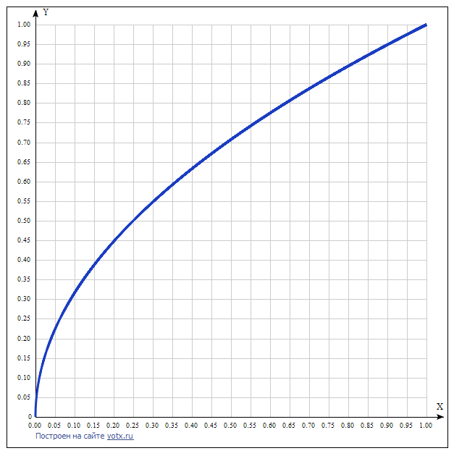

y(x)=√x [Таблица точек](javascript:void(0);)

|  |  |
| --- | --- |
| **x** | **y** |
| 0.00 | 0 |
| 0.05 | 0.224 |
| 0.10 | 0.316 |
| 0.15 | 0.387 |
| 0.20 | 0.447 |
| 0.25 | 0.5 |
| 0.30 | 0.548 |
| 0.35 | 0.592 |
| 0.40 | 0.632 |
| 0.45 | 0.671 |
| 0.50 | 0.707 |
| 0.55 | 0.742 |
| 0.60 | 0.775 |
| 0.65 | 0.806 |
| 0.70 | 0.837 |
| 0.75 | 0.866 |
| 0.80 | 0.894 |
| 0.85 | 0.922 |
| 0.90 | 0.949 |
| 0.95 | 0.975 |
| 1.00 | 1 |

y(x)=1/x

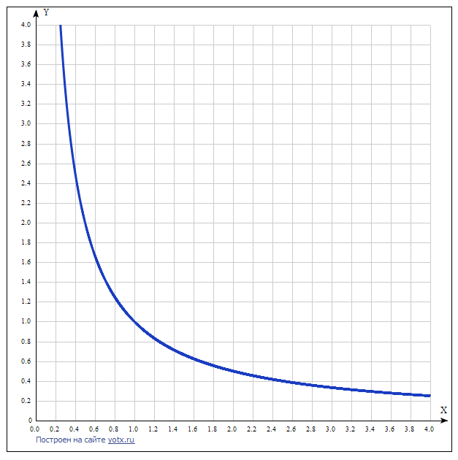

y(x)=1/x [Таблица точек](javascript:void(0);)

|  |  |
| --- | --- |
| **x** | **y** |
| 0.0 | - |
| 0.2 | 5 |
| 0.4 | 2.5 |
| 0.6 | 1.67 |
| 0.8 | 1.25 |
| 1.0 | 1 |
| 1.2 | 0.83 |
| 1.4 | 0.71 |
| 1.6 | 0.63 |
| 1.8 | 0.56 |
| 2.0 | 0.5 |
| 2.2 | 0.45 |
| 2.4 | 0.42 |
| 2.6 | 0.38 |
| 2.8 | 0.36 |
| 3.0 | 0.33 |
| 3.2 | 0.31 |
| 3.4 | 0.29 |
| 3.6 | 0.28 |
| 3.8 | 0.26 |
| 4.0 | 0.25 |