$$y=\frac{1}{2}sin2x$$
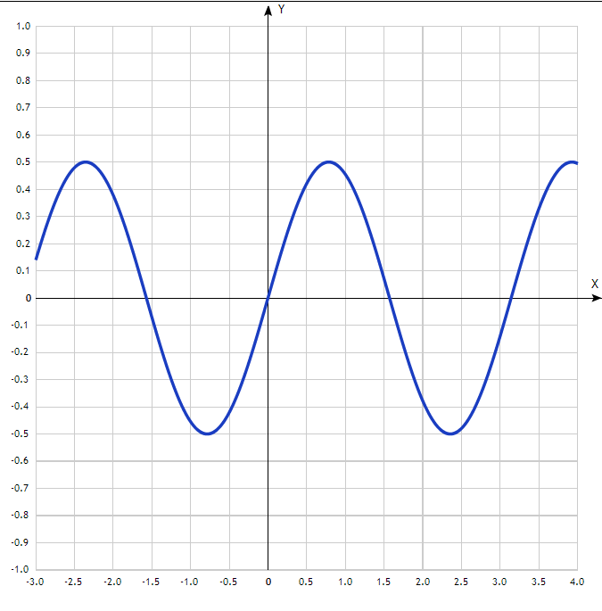

Таблица точек

x | y
-3.0 | 0.14
-2.5 | 0.48
-2.0 | 0.38
-1.5 | -0.07
-1.0 | -0.45
-0.5 | -0.42
0 | 0
0.5 | 0.42
1.0 | 0.45
1.5 | 0.07
2.0 | -0.38
2.5 | -0.48
3.0 | -0.14
3.5 | 0.33
4.0 | 0.49

$$y=arc\sin\left(x-1\right)-1$$
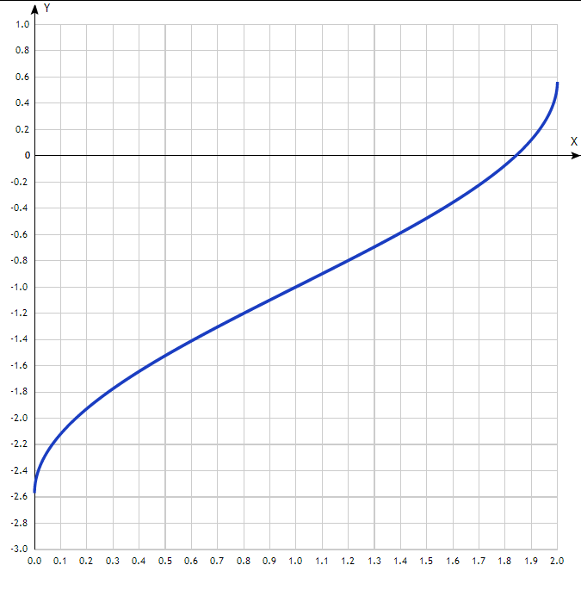
Таблица точек

x | y
0.0 | -2.57
0.1 | -2.12
0.2 | -1.93
0.3 | -1.78
0.4 | -1.64
0.5 | -1.52
0.6 | -1.41
0.7 | -1.3
0.8 | -1.2
0.9 | -1.1
1.0 | -1
1.1 | -0.9
1.2 | -0.8
1.3 | -0.7
1.4 | -0.59
1.5 | -0.48
1.6 | -0.36
1.7 | -0.22
1.8 | -0.07
1.9 | 0.12
2.0 | -

