**7th Grade English Test**

**Instructions:**

1. Answer all the questions.
2. Read each question and the options carefully.
3. Choose the correct answer by circling the corresponding letter (A, B, C, or D).
4. For the short essay, follow the instructions provided.

**Part I: Grammar (20 points)**

**1. Choose the correct form of the verb to complete the sentence.**

a. Yesterday I _________ my homework. (do)

b. There _________ two books on the shelf. (be)

c. Students _________ wear uniforms at our school. (must)

d. She _________ playing the piano now. (is)

A. did, are, must, is

B. do, is, must, are

C. did, are, have to, is

D. did, is, have to, are

**2. Fill in the blank with "there's" or "there are" to complete the sentence correctly.**

a. _________ a computer in the classroom.

b. _________ some students in the library.

c. _________ a basketball game in the gym.

d. _________ many books on the shelf.

A. There's, There's, There's, There's

B. There are, There are, There's, There are

C. There's, There are, There's, There are

D. There are, There's, There's, There are

**3. Choose the correct sentence with the correct form of "have to" or "must."**

a. We _________ wear a uniform to school.

b. She _________ finish her homework now.

c. You _________ arrive on time for the assembly.

d. He _________ go to the dentist yesterday.

A. Have to, Must, Have to, Must

B. Must, Have to, Have to, Have to

C. Have to, Must, Have to, Have to

D. Must, Have to, Must, Have to

**Part II: Vocabulary (10 points)**

**4. Match the school interior vocabulary with the correct pictures. Write the letter of the picture next to the word.**

1. A. Classroom b. Library c. Gym d. Cafeteria

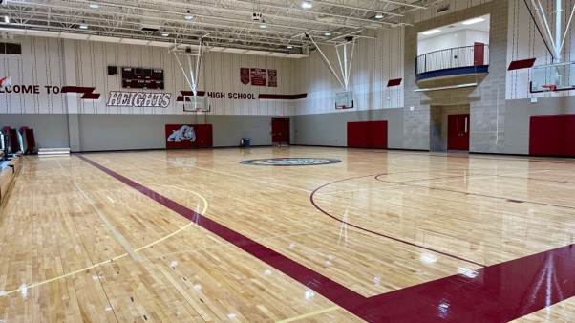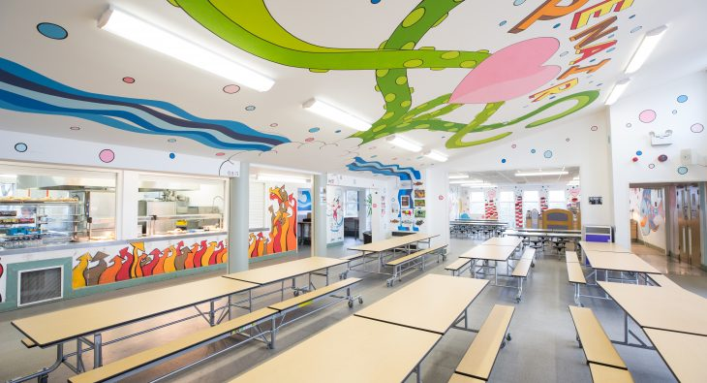

**Part III: School Rules (10 points)**

**5. Read the school rules below and decide if they are "Good" or "Not Good" rules.**

a. No running in the hallways.

b. Eating in the library is allowed.

c. Respect your teachers and classmates.

d. Tardiness to class is okay.

Good Rule: ____

Not Good Rule: ____

Good Rule: ____

Not Good Rule: ____

**Part IV: Short Essay (20 points)**

**6. Imagine you are a student at your school. Write a short essay (about 50 words) about your favorite place in your school. Explain why you like it and what you do there. Be sure to use proper grammar and punctuation in your essay.**

**Total Points: ____ / 60**