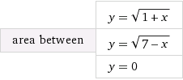

http://www4c.wolframalpha.com/Calculate/MSP/MSP96031g6d291ab8ia7bcg0000625dfgahf0g2c9ec?MSPStoreType=image/gif&s=63&w=315.&h=36.

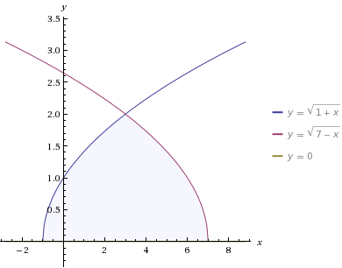

 integral_(-1)^3 sqrt(1+x) dx = 16\/3 ~~ 5.3333

 integral sqrt(1+x) dx = 2\/3 (x+1)^(3\/2)+constant

 integral sqrt(7-x) dx = -2\/3 (7-x)^(3\/2)+constant

 integral_3^7 sqrt(7-x) dx = 16\/3 ~~ 5.3333