http://www4b.wolframalpha.com/Calculate/MSP/MSP12301dec090i4ici9hdd000034ciae06679a2fa0?MSPStoreType=image/gif&s=51&w=77.&h=18.

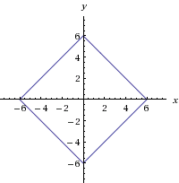

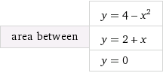

http://www4c.wolframalpha.com/Calculate/MSP/MSP554227611g6a3iga83300003bf0a35h7457efa1?MSPStoreType=image/gif&s=52&w=205.&h=36.

