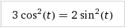
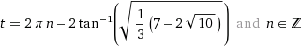
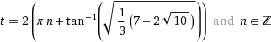
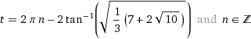
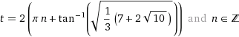
График функций 3cos²t и 2sin²t

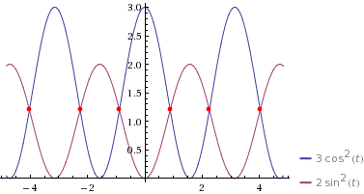

Значения х и у при разных значениях t
t | 0 | 1 | 2 | 3 | 4 | 5 | 6 | 7 | 8 | 9 | 10
3cos^2(t)=x | 3 | 0.876 | 0.520 | 2.940 | 1.282 | 0.241 | 2.766 | 1.705 | 0.064 | 2.491 | 2.112
2sin^2(t)=y | 0 | 1.416 | 1.6536 | 0.0398 | 1.1455 | 1.8391 | 0.1561 | 0.8633 | 1.9577 | 0.3397 | 0.5919

