https://znanija.com/task/53811762

**А1 (0:-3:1), А2 (-4:1:2), А3 (2:-1:5), А4 (3:1:-4)**

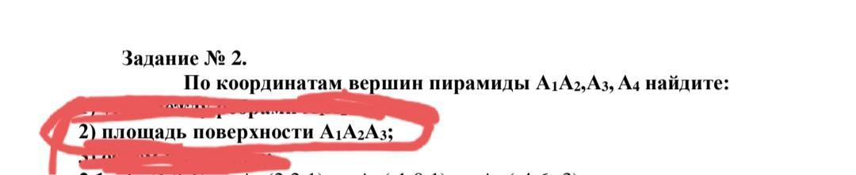

Находим длины сторон треугольника.

|  |  |  |  |  |  |  |  |  |
| --- | --- | --- | --- | --- | --- | --- | --- | --- |
| AB = | √((xB-xA)²+(yB-yA)²+(zB-zA)²) | = | 16 | 16 | 1 | 33 | **5,744563** | c |
| BC = | √((xC-xB)²+(yC-yB)²+(zC-zB)²) | = | 36 | 4 | 9 | 49 | **7** | a |
| AC = | √((xC-xA)²+(yC-yA)²+(zC-zA)²) | = | 4 | 4 | 16 | 24 | **4,898979** | b |

По формуле Герона находим площадь.

|  |  |  |  |  |  |  |
| --- | --- | --- | --- | --- | --- | --- |
| Периметр АВС Р = | | | 17,64354 | p - a | p - b | p - c |
| Полупериметр р= | | | 8,821771 | 1,821771 | 3,922792 | 3,077208 |
|  |  | **S =** | **√194 =** | **13,92839** |  |