|  |  |  |  |  |  |  |  |  |  |  |  |  |  |  |  |  |  |  |
| --- | --- | --- | --- | --- | --- | --- | --- | --- | --- | --- | --- | --- | --- | --- | --- | --- | --- | --- |
| 1 | 1 | 1 | -2 |  | 1 | 1 | 1 | -2 |  |  |  | |  | | --- | |  | |  |  |  |  |  |
| 2 | 3 | -1 | 1 |  | 2 | |  | | --- | | 3 | | -1 | 1 | 3 | -1 |  |  |  |  |  |  |  |
| 4 | -2 | -6 | 0 |  | 4 | -2 | -6 | 0 | -2 | -6 |  |  |  |  |  |  |  |
| 5 | 4 | -5 | 2 |  | 5 | 4 | -5 | 2 | 4 | -5 |  |  |  |  |  |  |  |
| det= | 18 | найден | в | Excel | det= | -6 |  |  |  |  |  |  |  |  |  |  |  |
|  |  |  |  |  |  | -36 | 0 | 10 |  |  |  |  |  |  |  |  |  |
|  |  |  |  |  |  | 4 | 0 | -24 | = | -6 |  |  |  |  |  |  |  |
|  |  |  |  |  |  |  |  |  |  |  |  |  |  |  |  |  |  |
| |  | | --- | | 1 | | 1 | 1 | -2 |  |  |  |  | 1 | 1 | 1 | -2 | |  | | --- | |  | |  |  |  |  |  |
| 2 | 3 | -1 | 1 | 2 | -1 |  |  | 2 | 3 | -1 | 1 |  | **2** | **3** | **1** | 2 | 3 |
| 4 | -2 | -6 | 0 | 4 | -6 |  |  | 4 | -2 | -6 | 0 |  | **4** | **-2** | **0** | 4 | -2 |
| 5 | 4 | -5 | 2 | 5 | -5 |  |  | 5 | 4 | -5 | 2 |  | **5** | **4** | **2** | 5 | 4 |
| det= | -6 |  |  |  |  |  |  | det= | -6 |  |  |  |  |  |  |  |  |
|  |  | -24 | 0 | -20 |  |  |  |  |  |  |  |  | -8 | 0 | 16 |  |  |
|  |  | -8 | 0 | -30 | = | -6 |  |  |  |  |  |  | 24 | 0 | -10 | = | -6 |
|  |  |  |  |  |  |  |  |  |  |  |  |  |  |  |  |  |  |
| 1 | 1 | 1 | -2 |  |  |  |  |  |  |  |  |  |  |  |  |  |  |
| 2 | 3 | -1 | 1 | |  | | --- | |  | | **2** | **3** | **-1** | 2 | 3 |  |  |  |  |  |  |  |  |
| 4 | -2 | -6 | 0 |  | **4** | **-2** | **-6** | 4 | -2 |  |  |  |  |  |  |  |  |
| 5 | 4 | -5 | 2 |  | **5** | **4** | **-5** | 5 | 4 |  |  |  |  |  |  |  |  |
| det= | 12 |  |  |  |  |  |  |  |  |  |  |  |  |  |  |  |  |
|  |  |  |  |  | 20 | -90 | -16 |  |  |  |  |  |  |  |  |  |  |
|  |  |  |  |  | -60 | -48 | 10 | = | 12 |  |  |  |  |  |  |  |  |
|  |  |  |  |  |  |  |  |  |  |  |  |  |  |  |  |  |  |

Общий опред = 18 Он находится по формуле

F1*K7-B9*G15+K9*R15-D17*J23

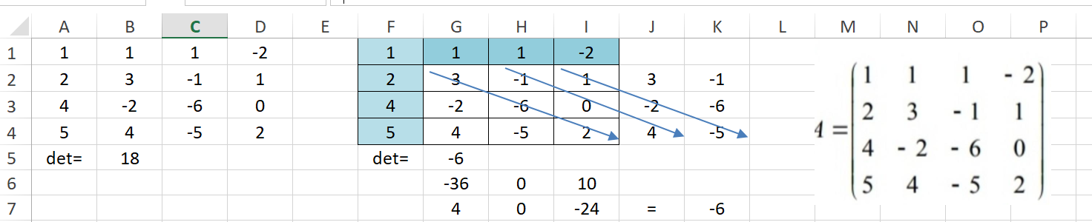

б)

