https://znanija.com/task/24776497 y=-x³+3x+2
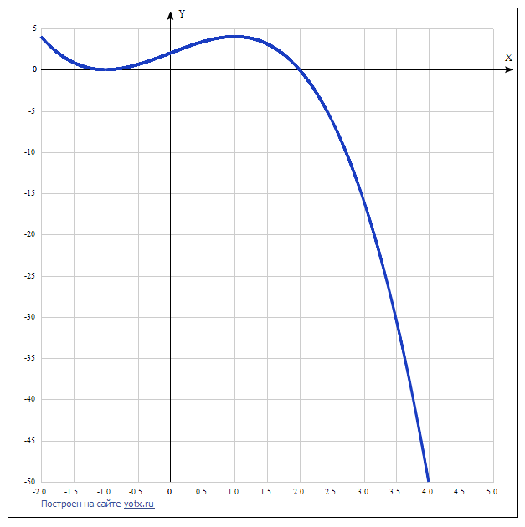

x | y
-2.0 | 4
-1.5 | 0.9
-1.0 | 0
-0.5 | 0.6
0 | 2
0.5 | 3.4
1.0 | 4
1.5 | 3.1
2.0 | 0
2.5 | -6.1
3.0 | -16
3.5 | -30.4
4.0 | -50
4.5 | -75.6
5.0 | -108

