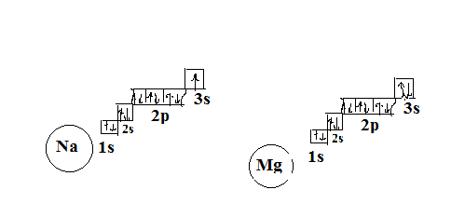

Na: 1s22s22p63s1 Mg: 1s22s22p63s2

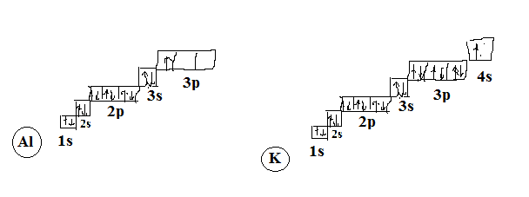

Al: 1s22s22p63s23p1 K: 1s22s22p63s23p64s1