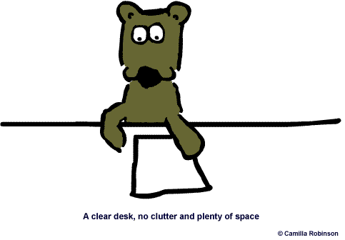
Let’s revise Verb Tenses.

Fill in the following blanks using the correct forms of the verbs in brackets. Use simple present, present continuous, simple past, and going to.
Tip! Highlight time markers and read the whole sentence to get a clear idea of what it is about.

- Henry usually _______________ (wake) up at 8 o'clock.
- My brother and my sister _______________ (have) breakfast at the moment.
- Peter _______________ (buy) a new bicycle yesterday.
- We _______________ (live) in Córdoba, Argentina.
- I _______________ (do) my Maths homework tonight.
- Be careful! Somebody_______________ (follow) us.
- My father never _______________ (drink) Coke before he _______________ (go) to bed. He _______________(say) it _______________(keep) him awake.
- Neil: Where ___________ you _______________ (go) last Sunday?
Laura: _______________ (go) to the cinema.
- “Look, my sister is not at home right now, but don't worry. She will phone you as soon as she_______________ (come) back” .
- I _______________ (not see) my friends last night at the party, I _____________ (feel) like a fish out of water.
- My grandmother _______________ (go) to church every Sunday.
- Please_______________ (call) me when the news_______________ (start) .
- Peter: _________ Tom ________________(pack) his suitcases yesterday?
Sam: Yes, he did. You know how obsessed he is, he always __________________(want) to have everything perfectly organised.
- ___________ Kevin always_________________ (start) work so late? If he ______________(continue) like this, he ___________________________(lose) his job.
- I overslept!!! I ___________________(phone) to see if they __________ still_____________ (wait) for me.
- Sue _______________ (sell) her car last Sunday. Now she ______________(have) the money to buy a new one.
- My father _____________(leave) to work very early in the morning so, he never_____________ (have) breakfast at home. He usually _______________(have) a cup of coffee in his office.
- I_____________________ (visit) my grandparents next week.

