https://znanija.com/task 24620353 $y=x^{3}-1$
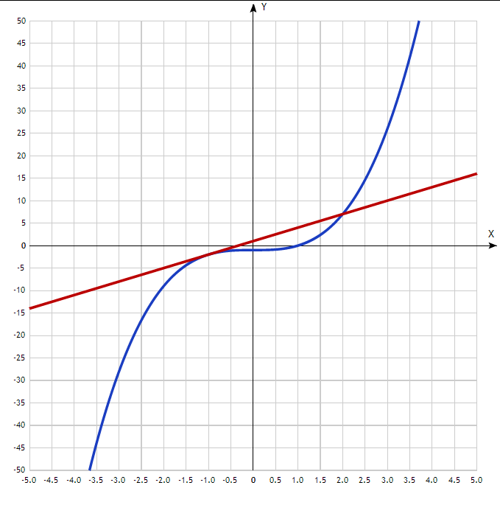
Таблица точек

x | y
-5.0 | -126
-4.5 | -92.1
-4.0 | -65
-3.5 | -43.9
-3.0 | -28
-2.5 | -16.6
-2.0 | -9
-1.5 | -4.4
-1.0 | -2
-0.5 | -1.1
0 | -1
0.5 | -0.9
1.0 | 0
1.5 | 2.4
2.0 | 7
2.5 | 14.6
3.0 | 26
3.5 | 41.9
4.0 | 63
4.5 | 90.1
5.0 | 124

